Organic Curved Shapes
# Source: AI Source: Provided by: [Data Path: Persons Table -> ID Column: 1, Name_En Column: Motasem Essam] -> From: [ChatGPT] on [7/25/2026]
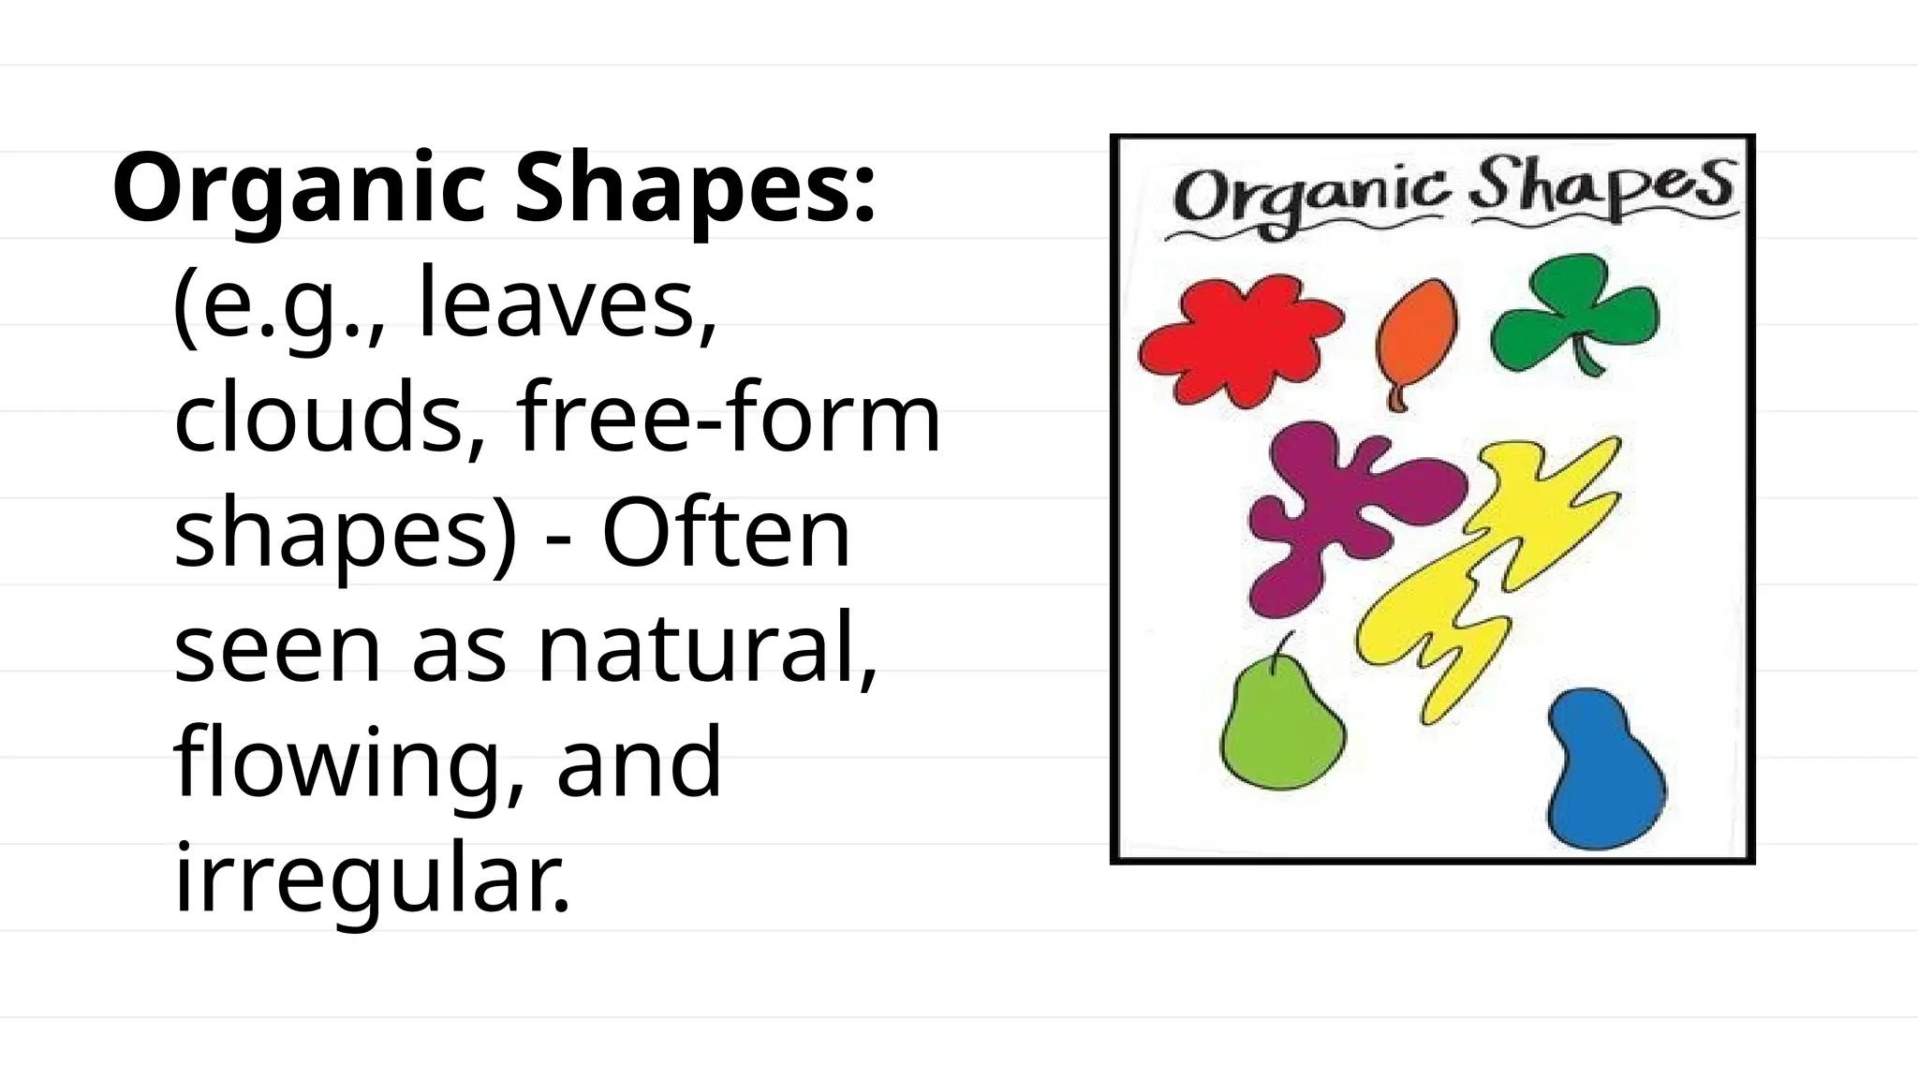
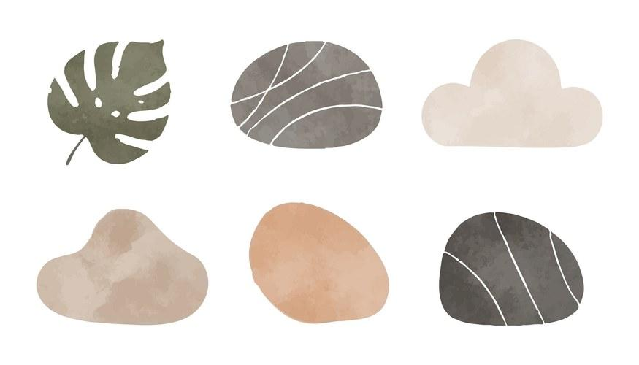
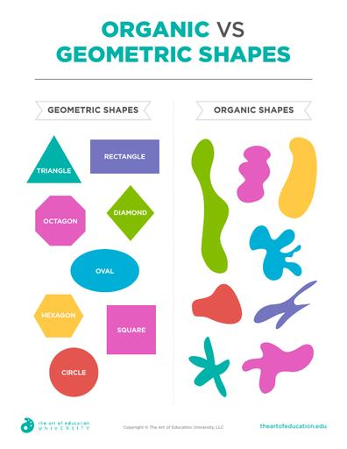
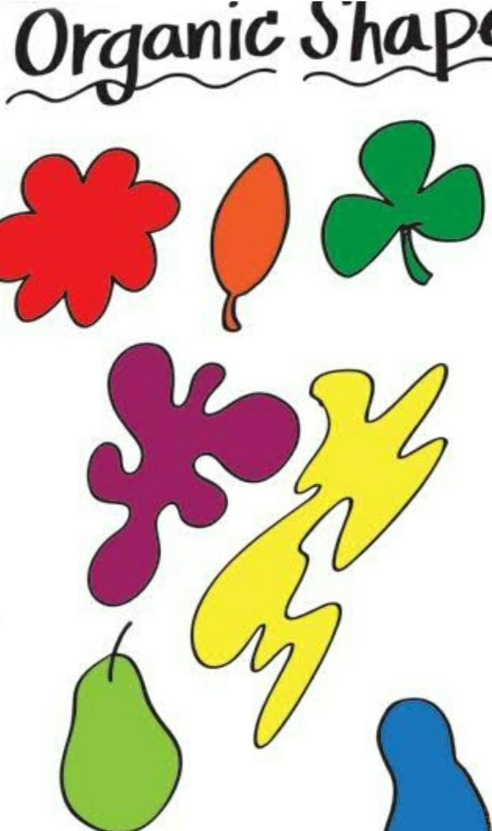
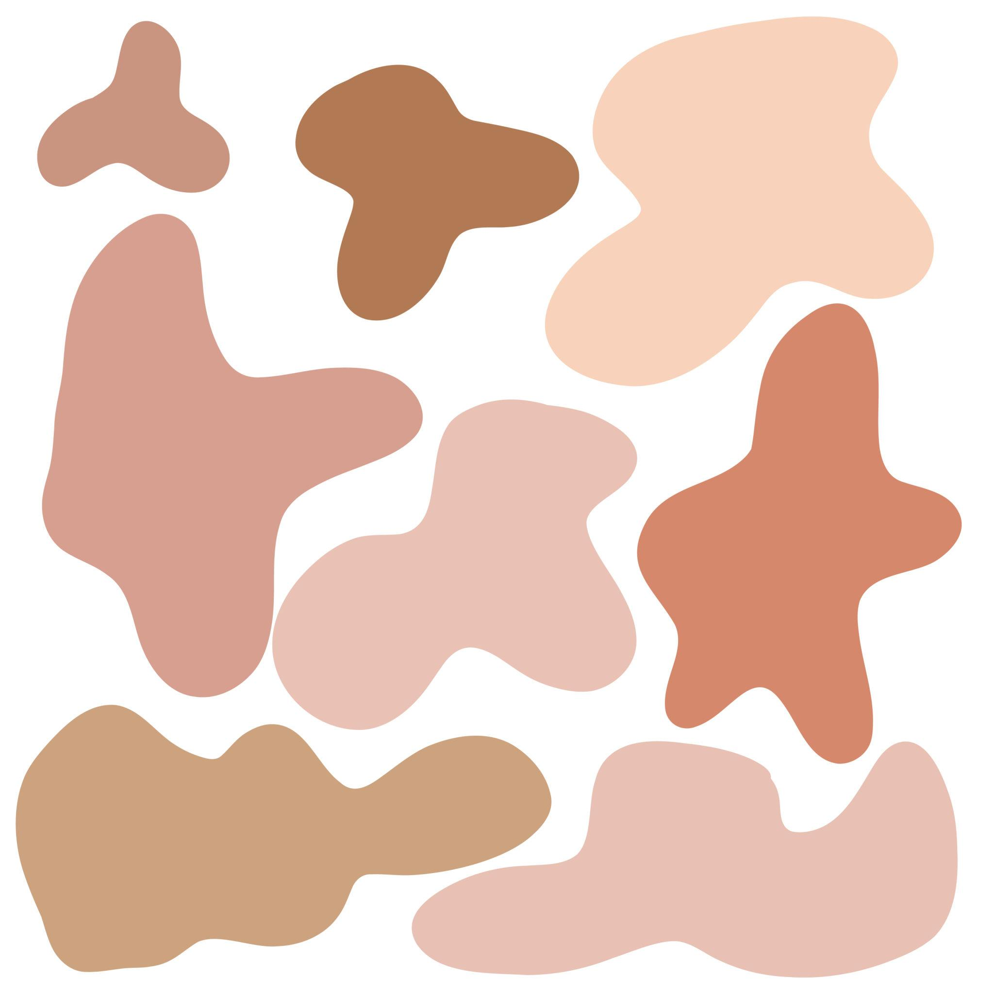
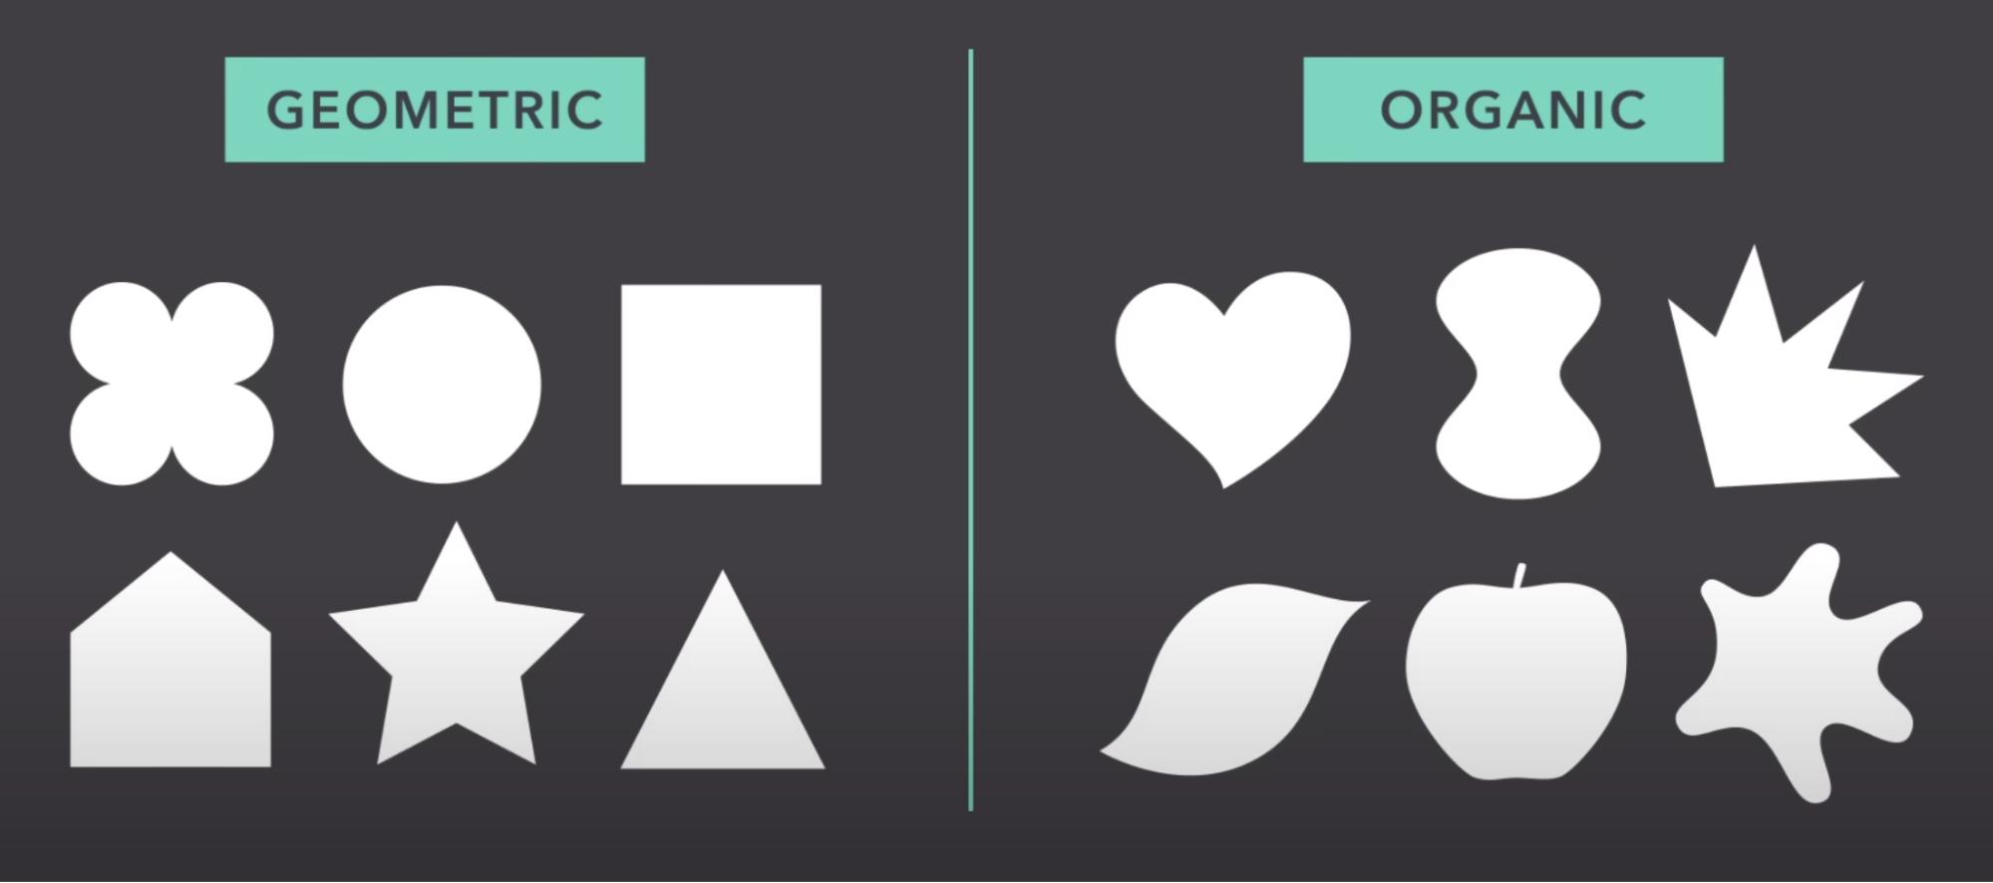

Definition
# Source: AI Source: Provided by: [Data Path: Persons Table -> ID Column: 1, Name_En Column: Motasem Essam] -> From: [ChatGPT] on [7/25/2026]
An Organic Curved Shape is an irregular shape characterized by smooth, flowing, and often asymmetrical curves that resemble forms found in nature or living organisms.
Organic curved shapes do not usually follow precise geometric rules such as constant radius or equal side lengths.
$$\boxed{\text{Organic Curved Shape}=\text{Irregular Curved Form resembling natural or living forms}}$$

Characteristics
# Source: AI Source: Provided by: [Data Path: Persons Table -> ID Column: 1, Name_En Column: Motasem Essam] -> From: [ChatGPT] on [7/25/2026]
An organic curved shape typically:
- Has a curved boundary.
- Has irregular or variable curvature.
- Does not require equal dimensions.
- Often lacks perfect symmetry.
- Has smooth, flowing transitions.
- May resemble natural or biological forms.
- Can be either open or closed.
- Does not necessarily have a simple standard geometric equation.

Examples

1. Leaf-Like Shapes
# Source: AI Source: Provided by: [Data Path: Persons Table -> ID Column: 1, Name_En Column: Motasem Essam] -> From: [ChatGPT] on [7/25/2026]1
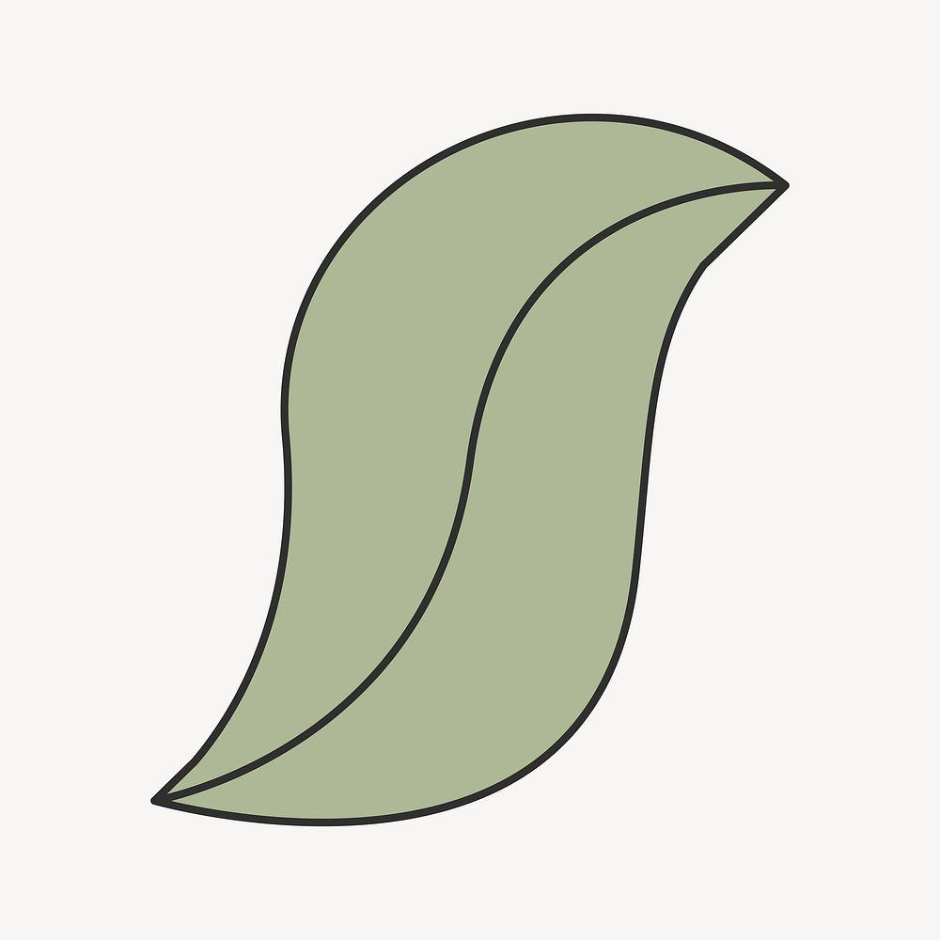
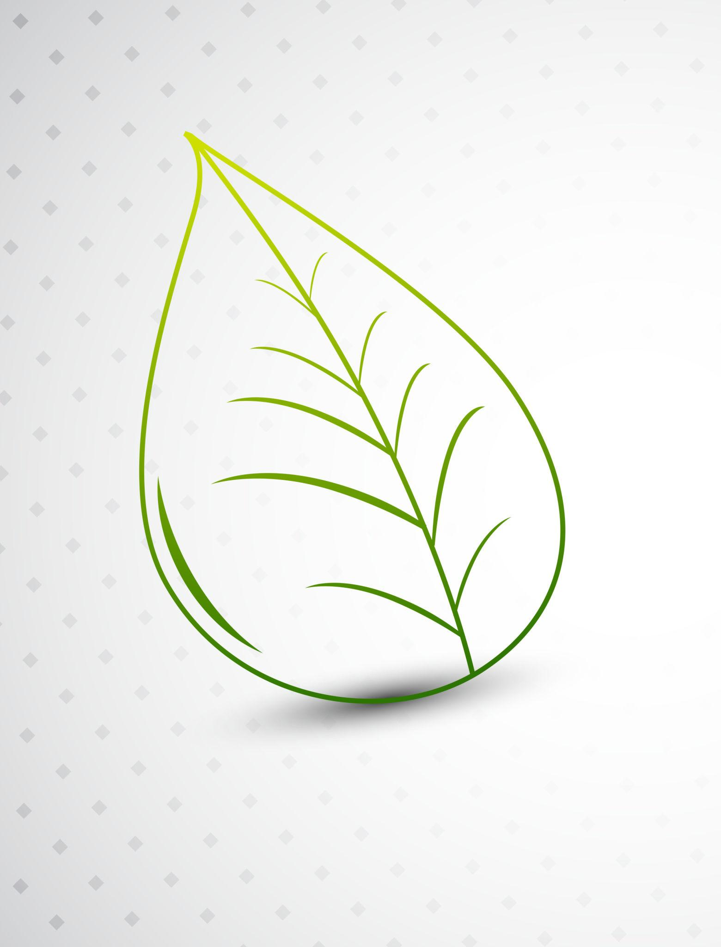
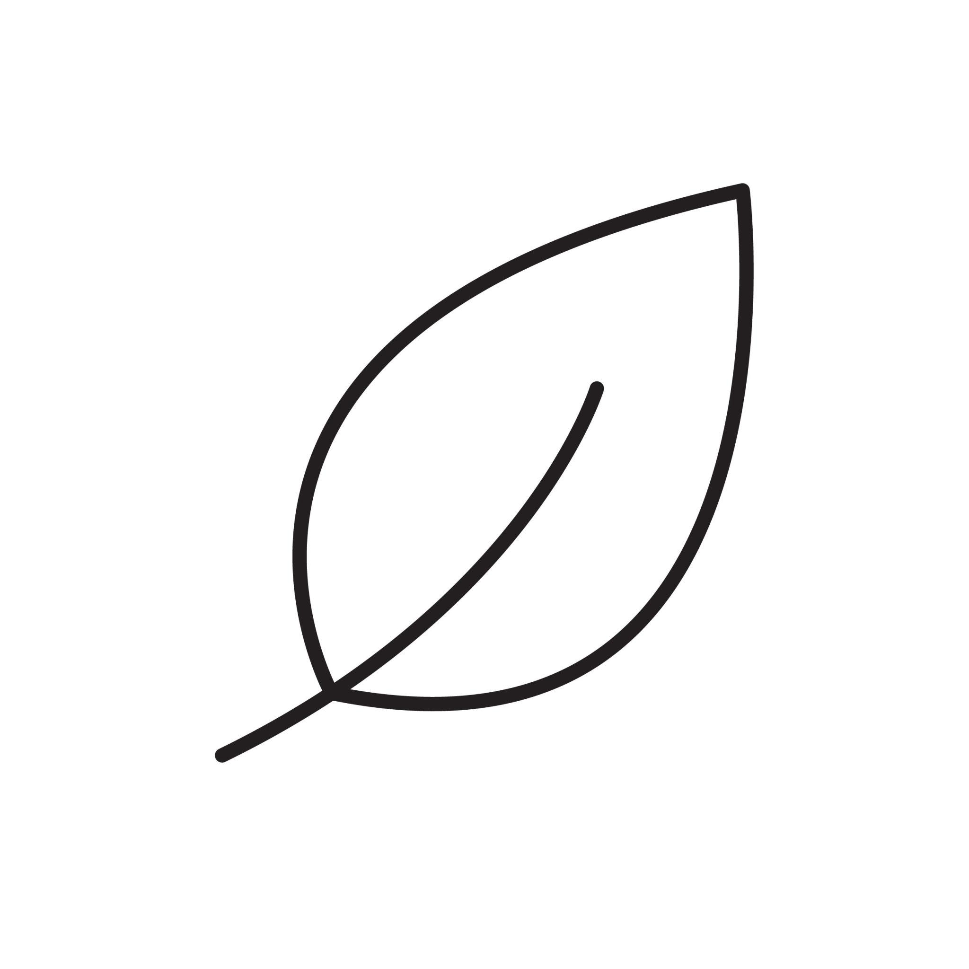
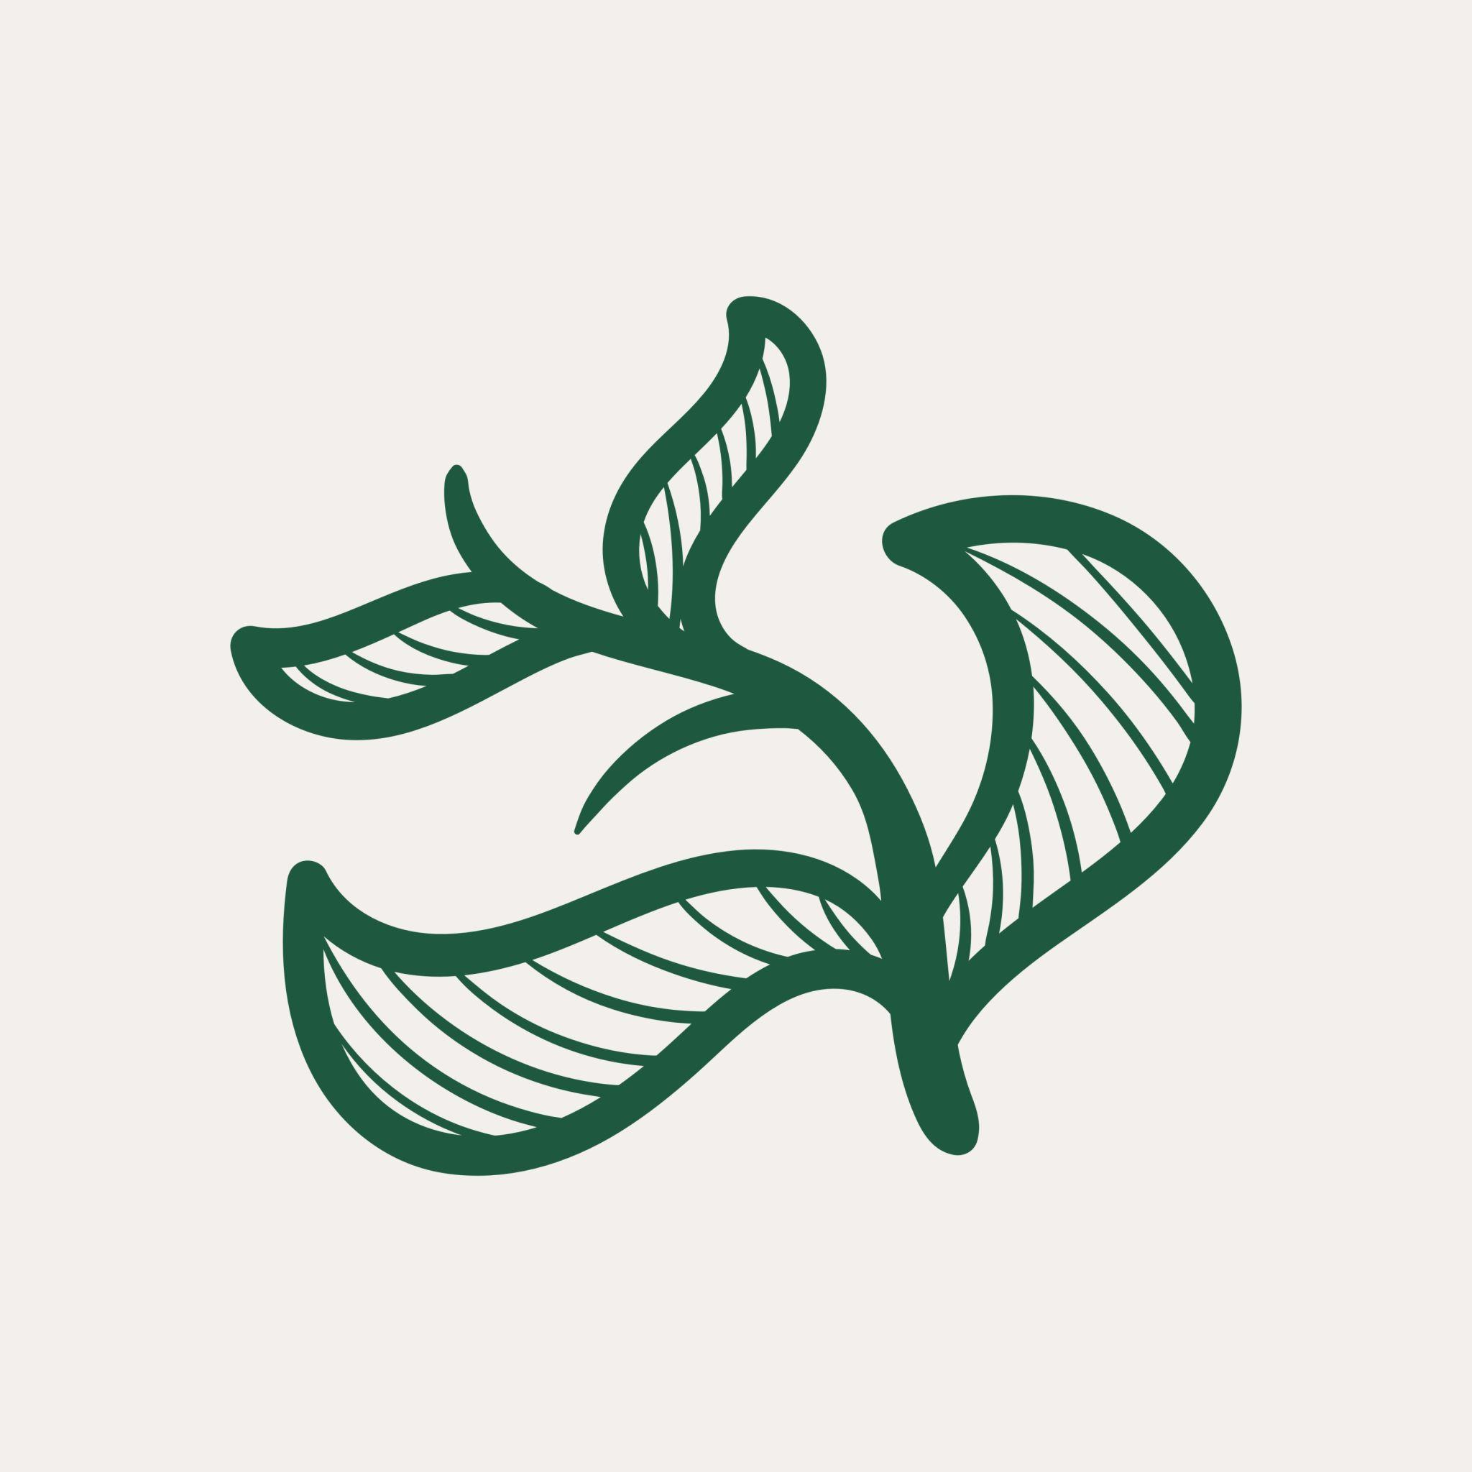
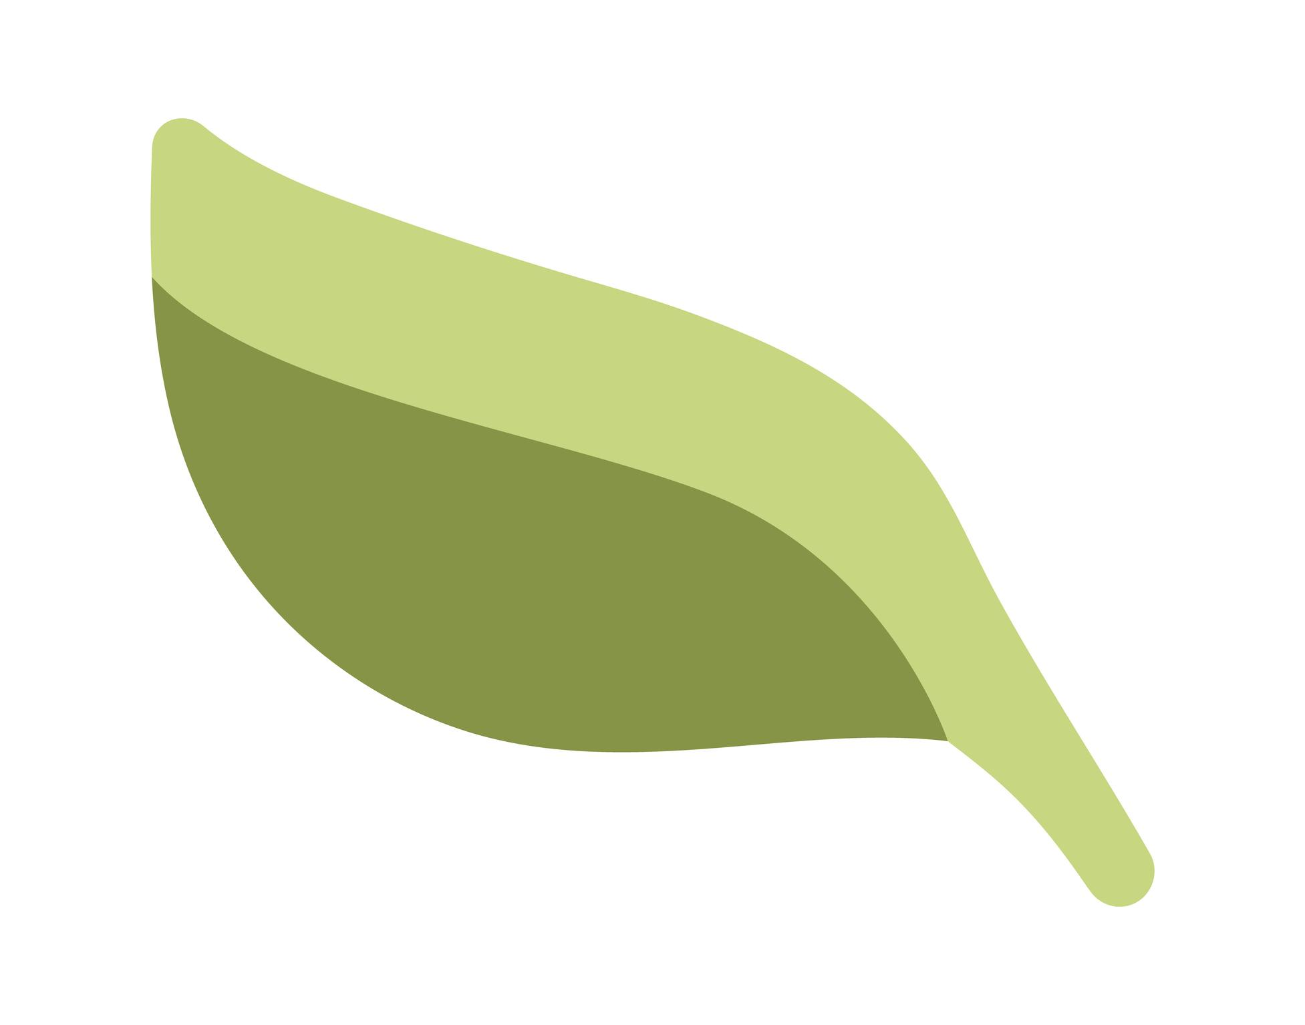
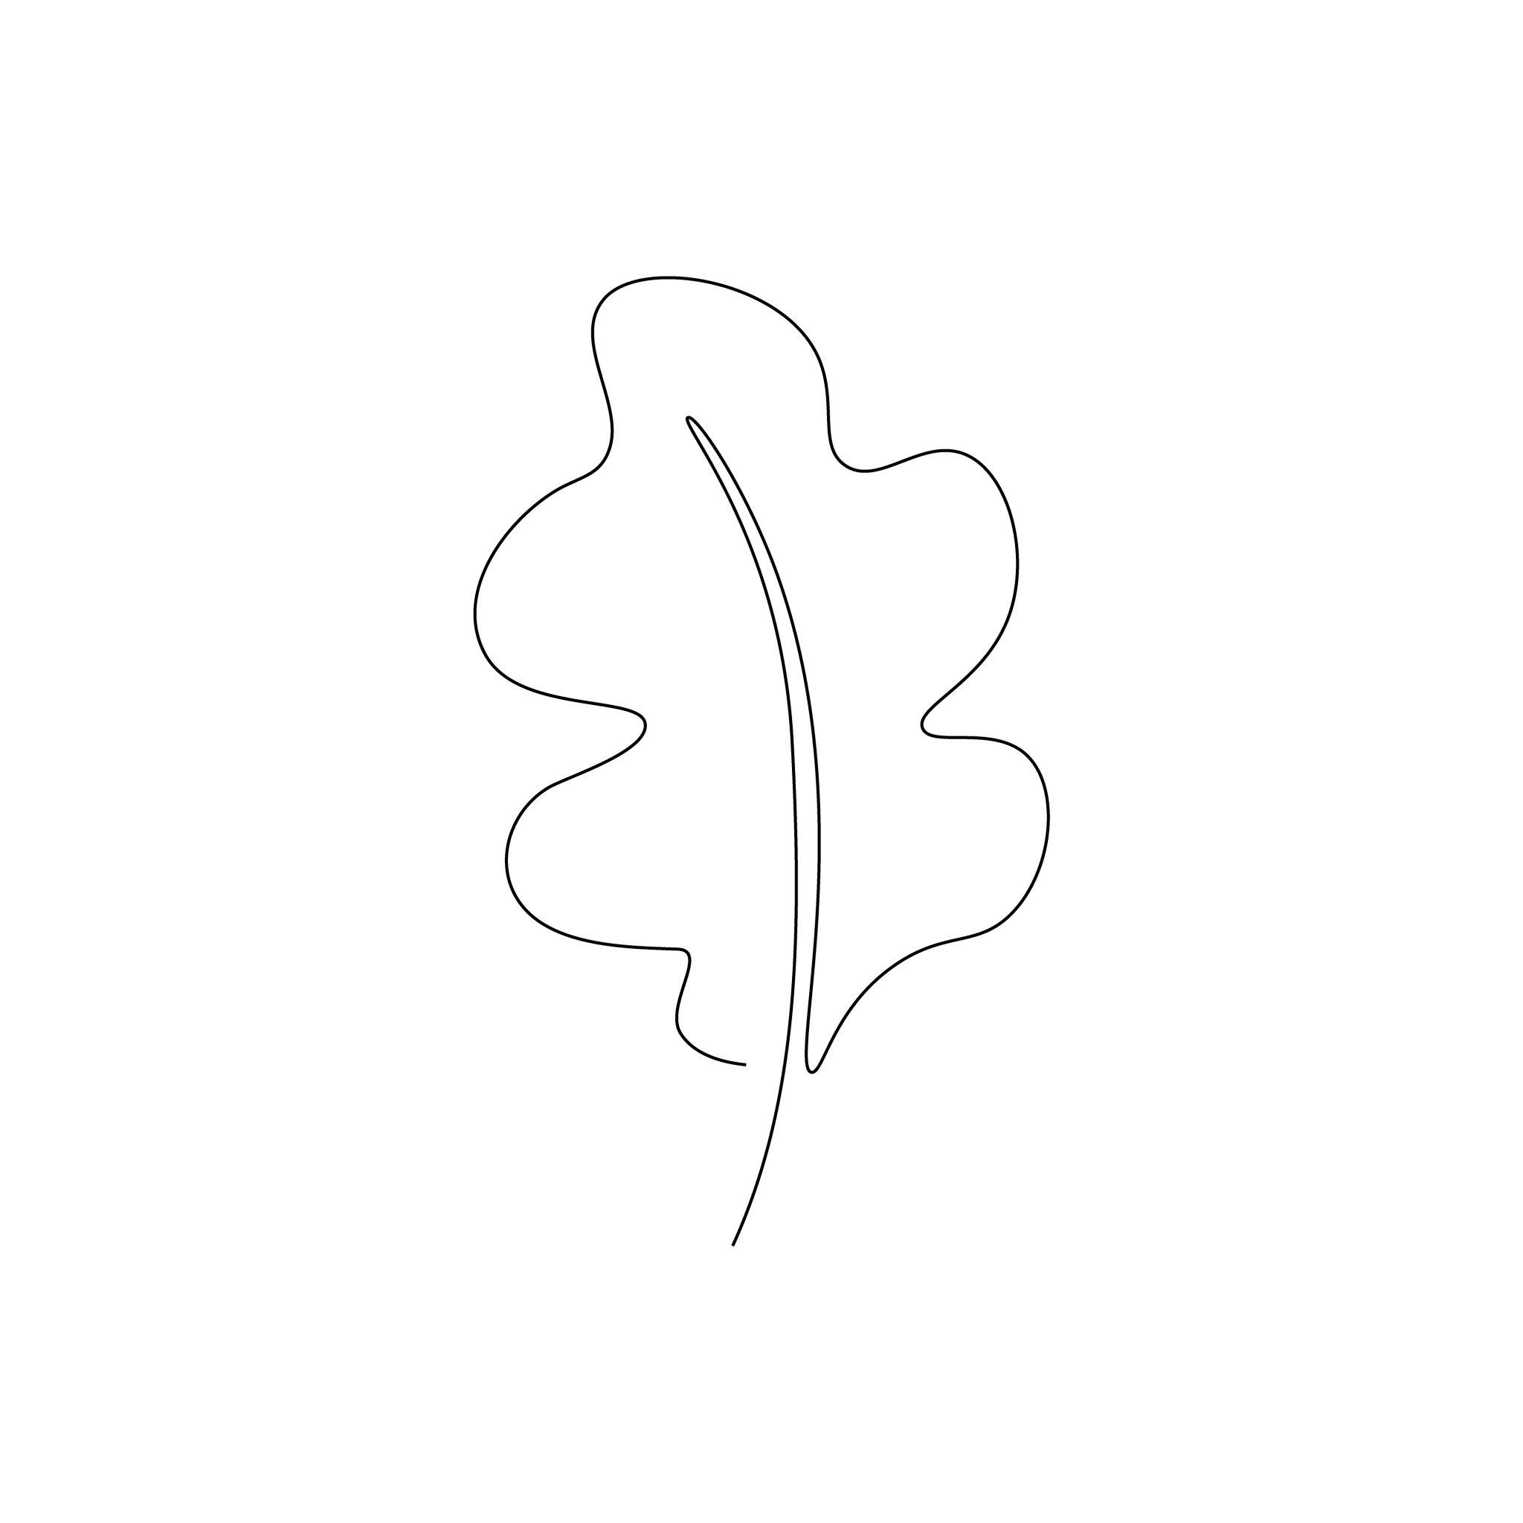
Leaf outlines are common examples of organic curved shapes because their boundaries contain naturally varying curves.

2. Cloud-Like Shapes
# Source: AI Source: Provided by: [Data Path: Persons Table -> ID Column: 1, Name_En Column: Motasem Essam] -> From: [ChatGPT] on [7/25/2026]
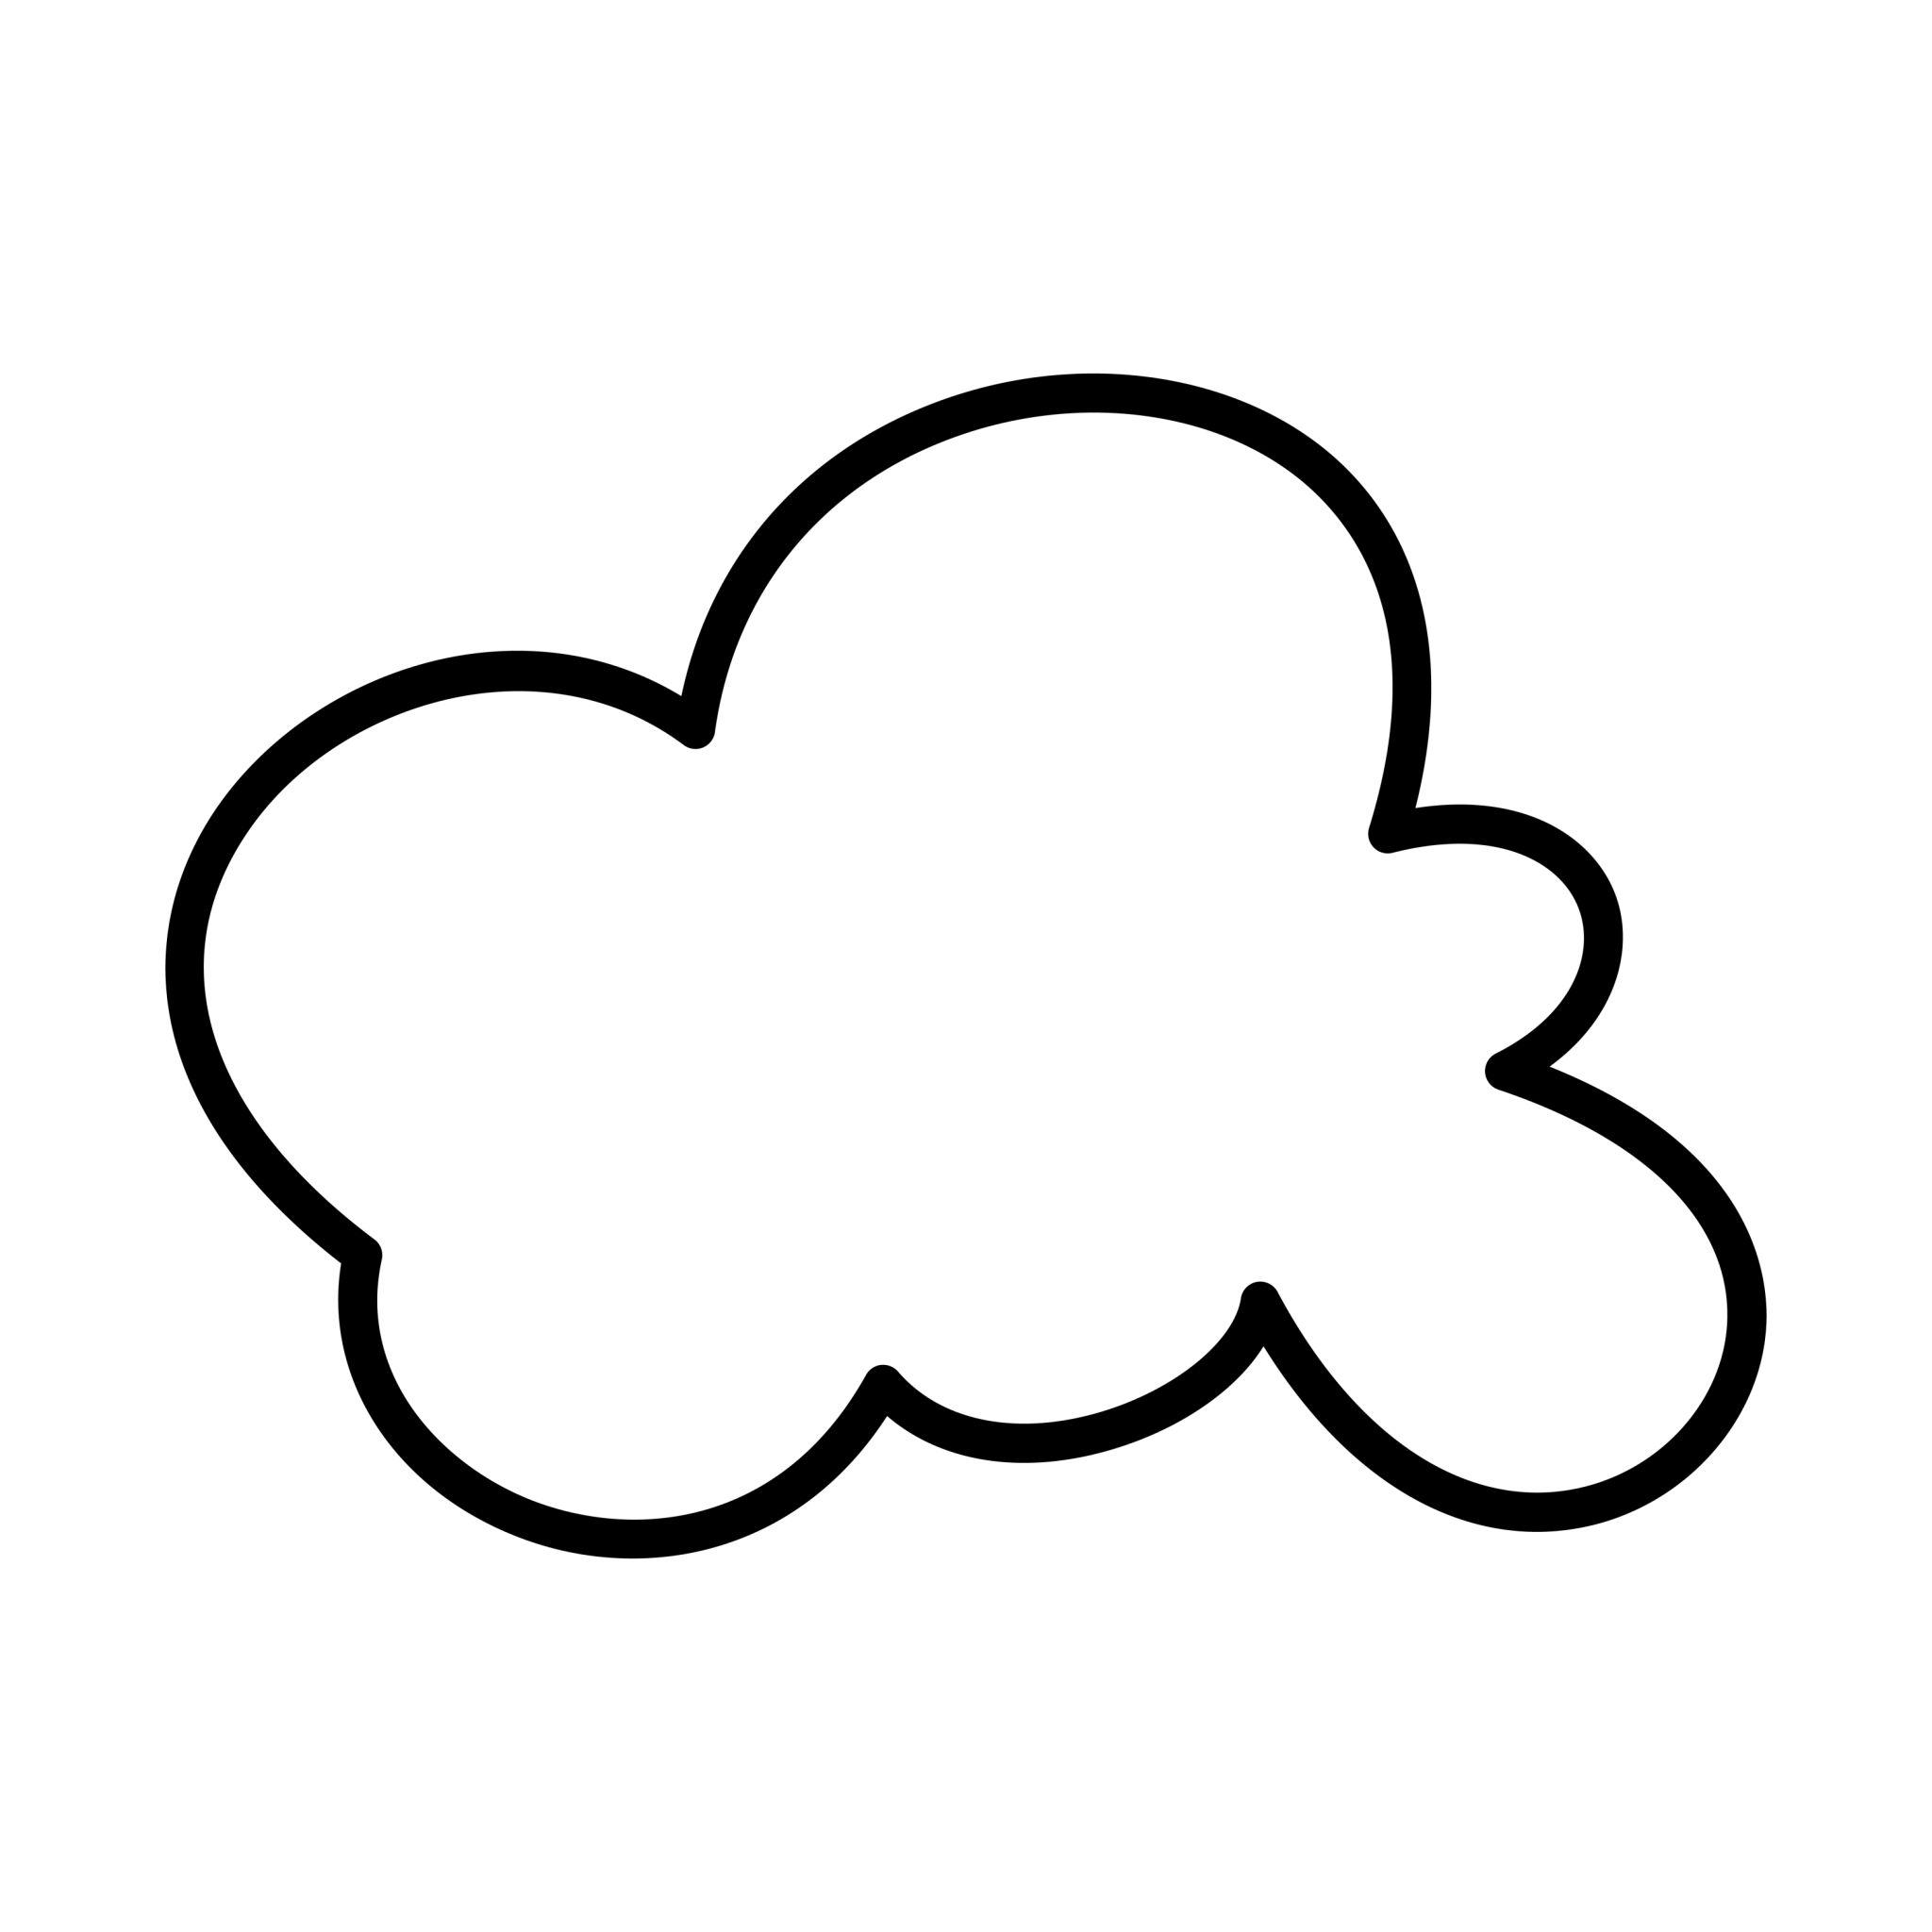
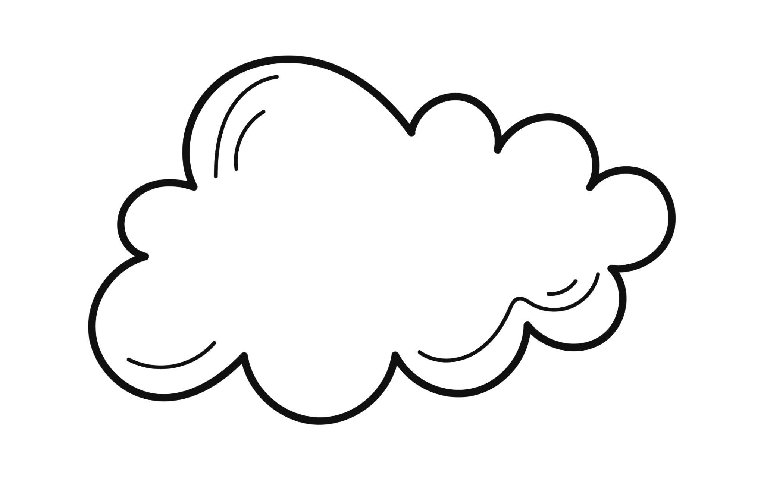
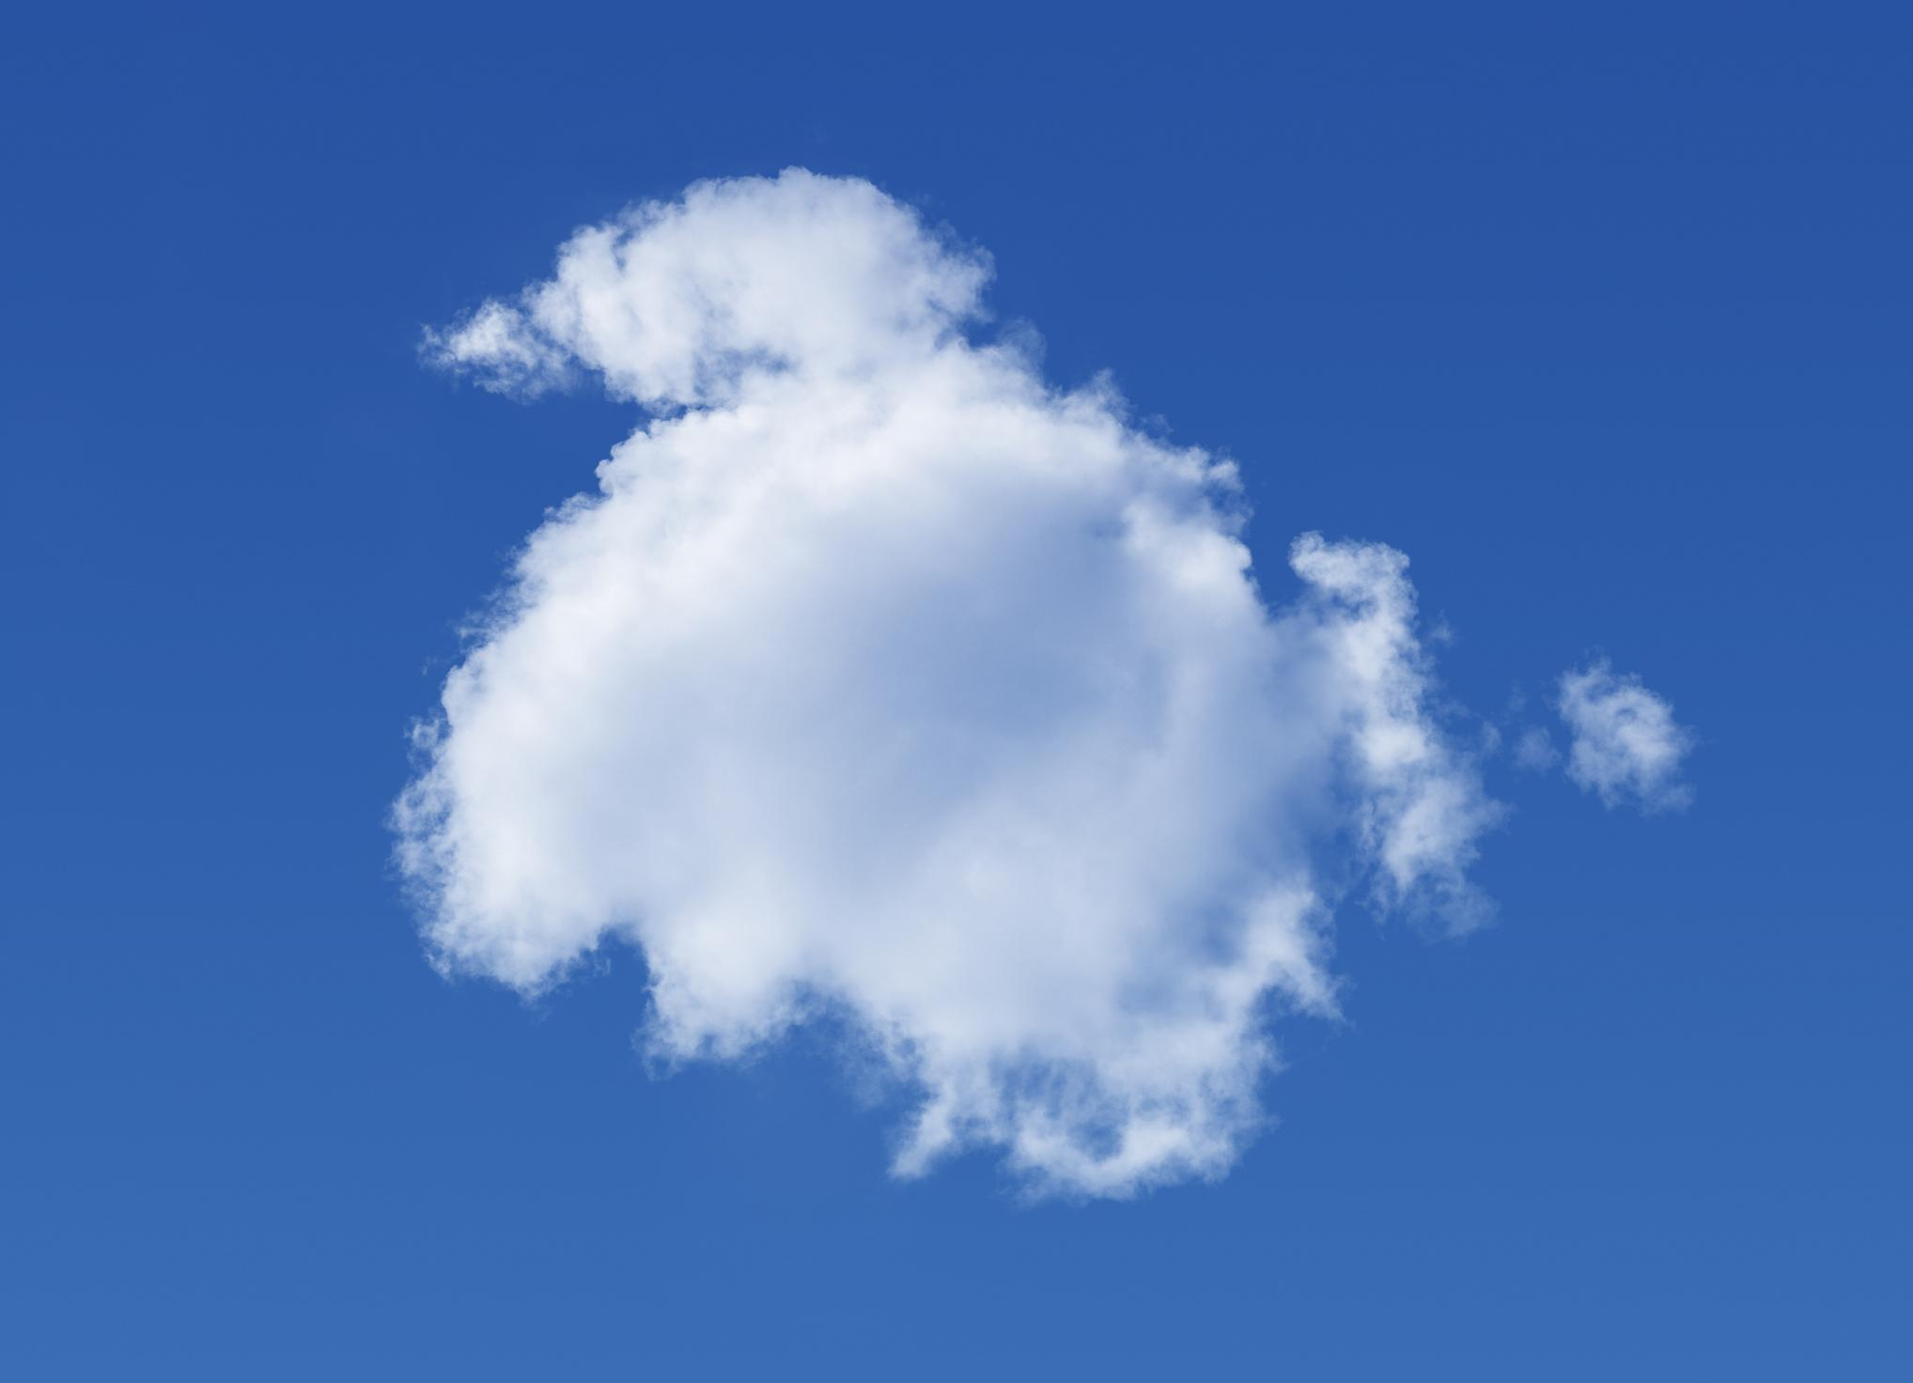
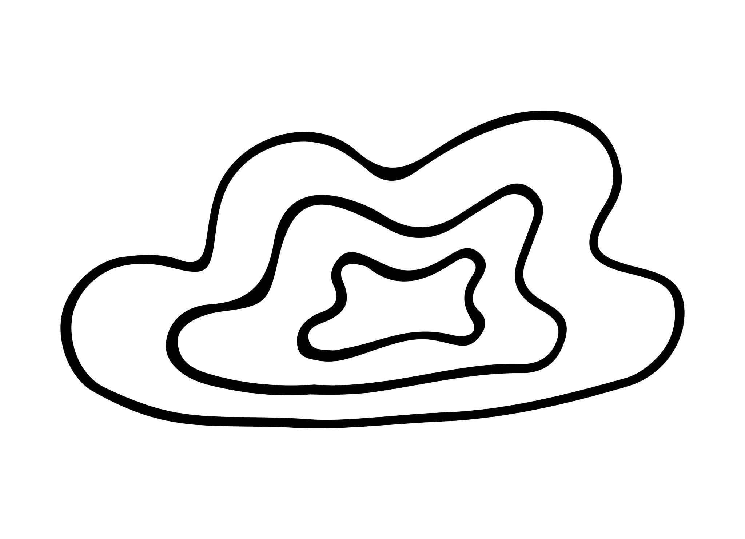
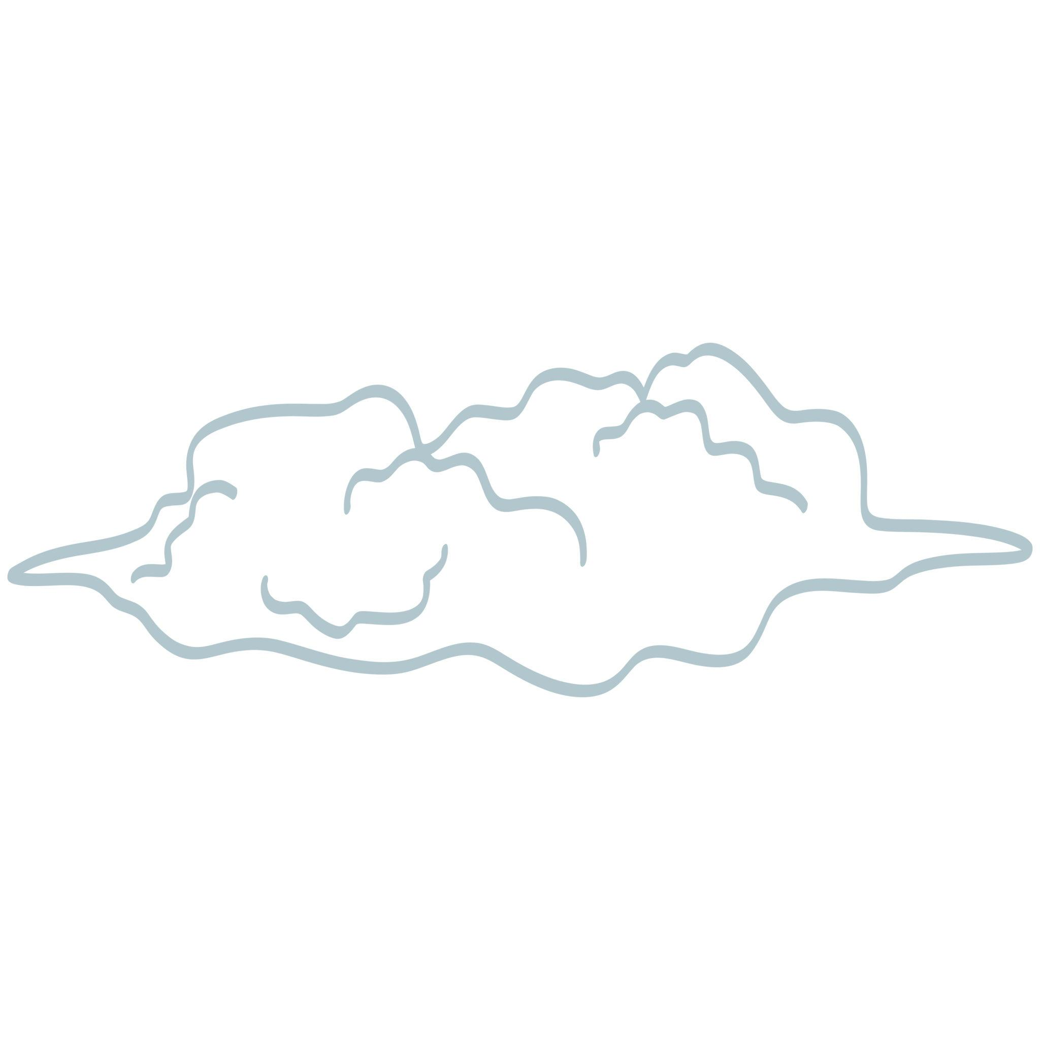
Cloud-like forms have smooth, continuously changing curved boundaries.

3. Blob Shapes
# Source: AI Source: Provided by: [Data Path: Persons Table -> ID Column: 1, Name_En Column: Motasem Essam] -> From: [ChatGPT] on [7/25/2026]
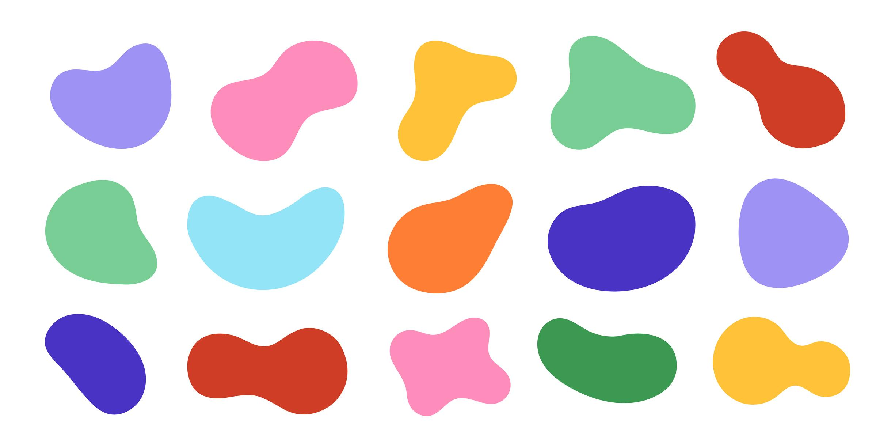
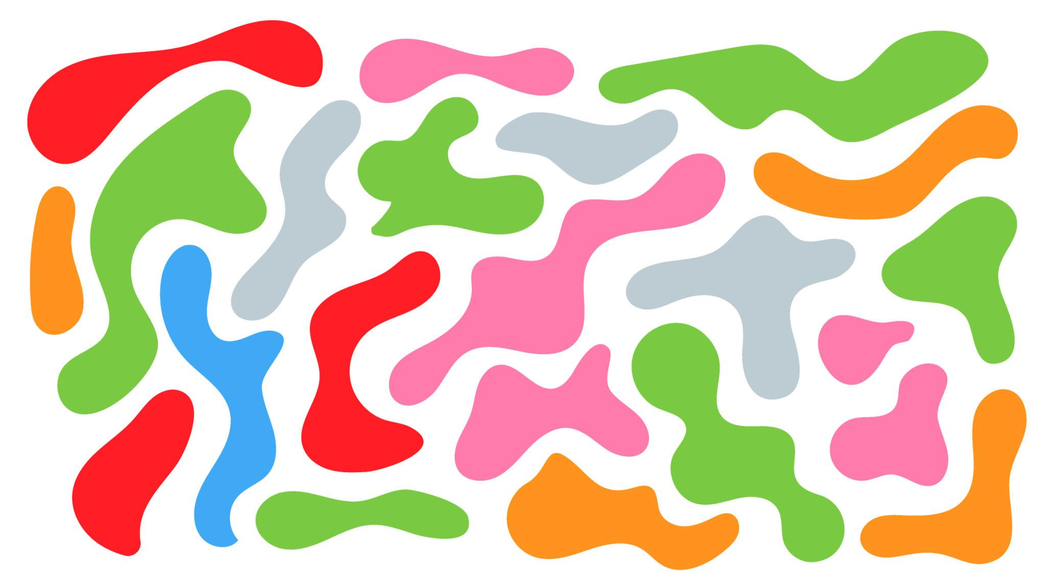
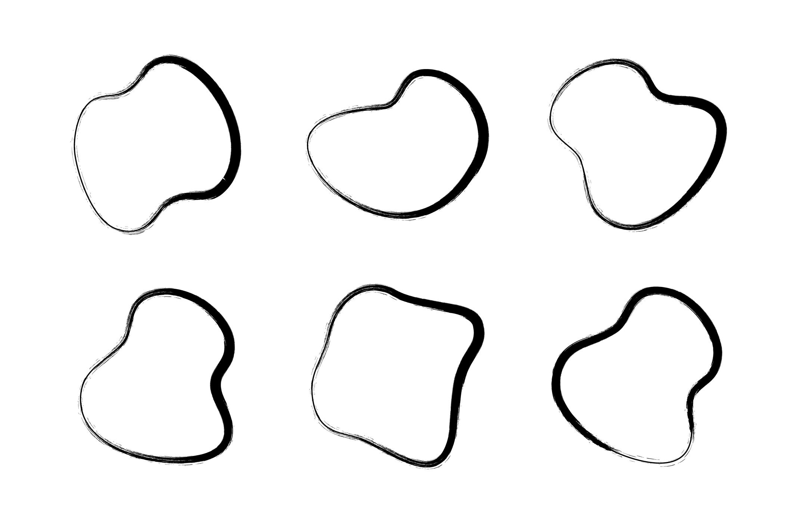
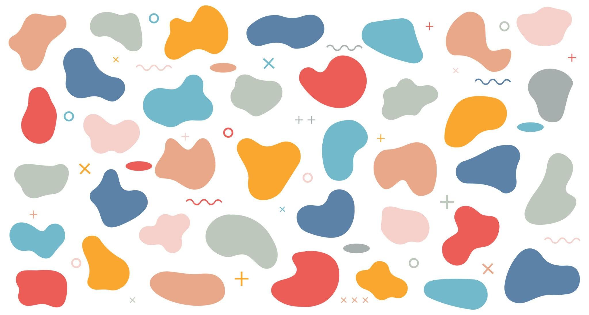
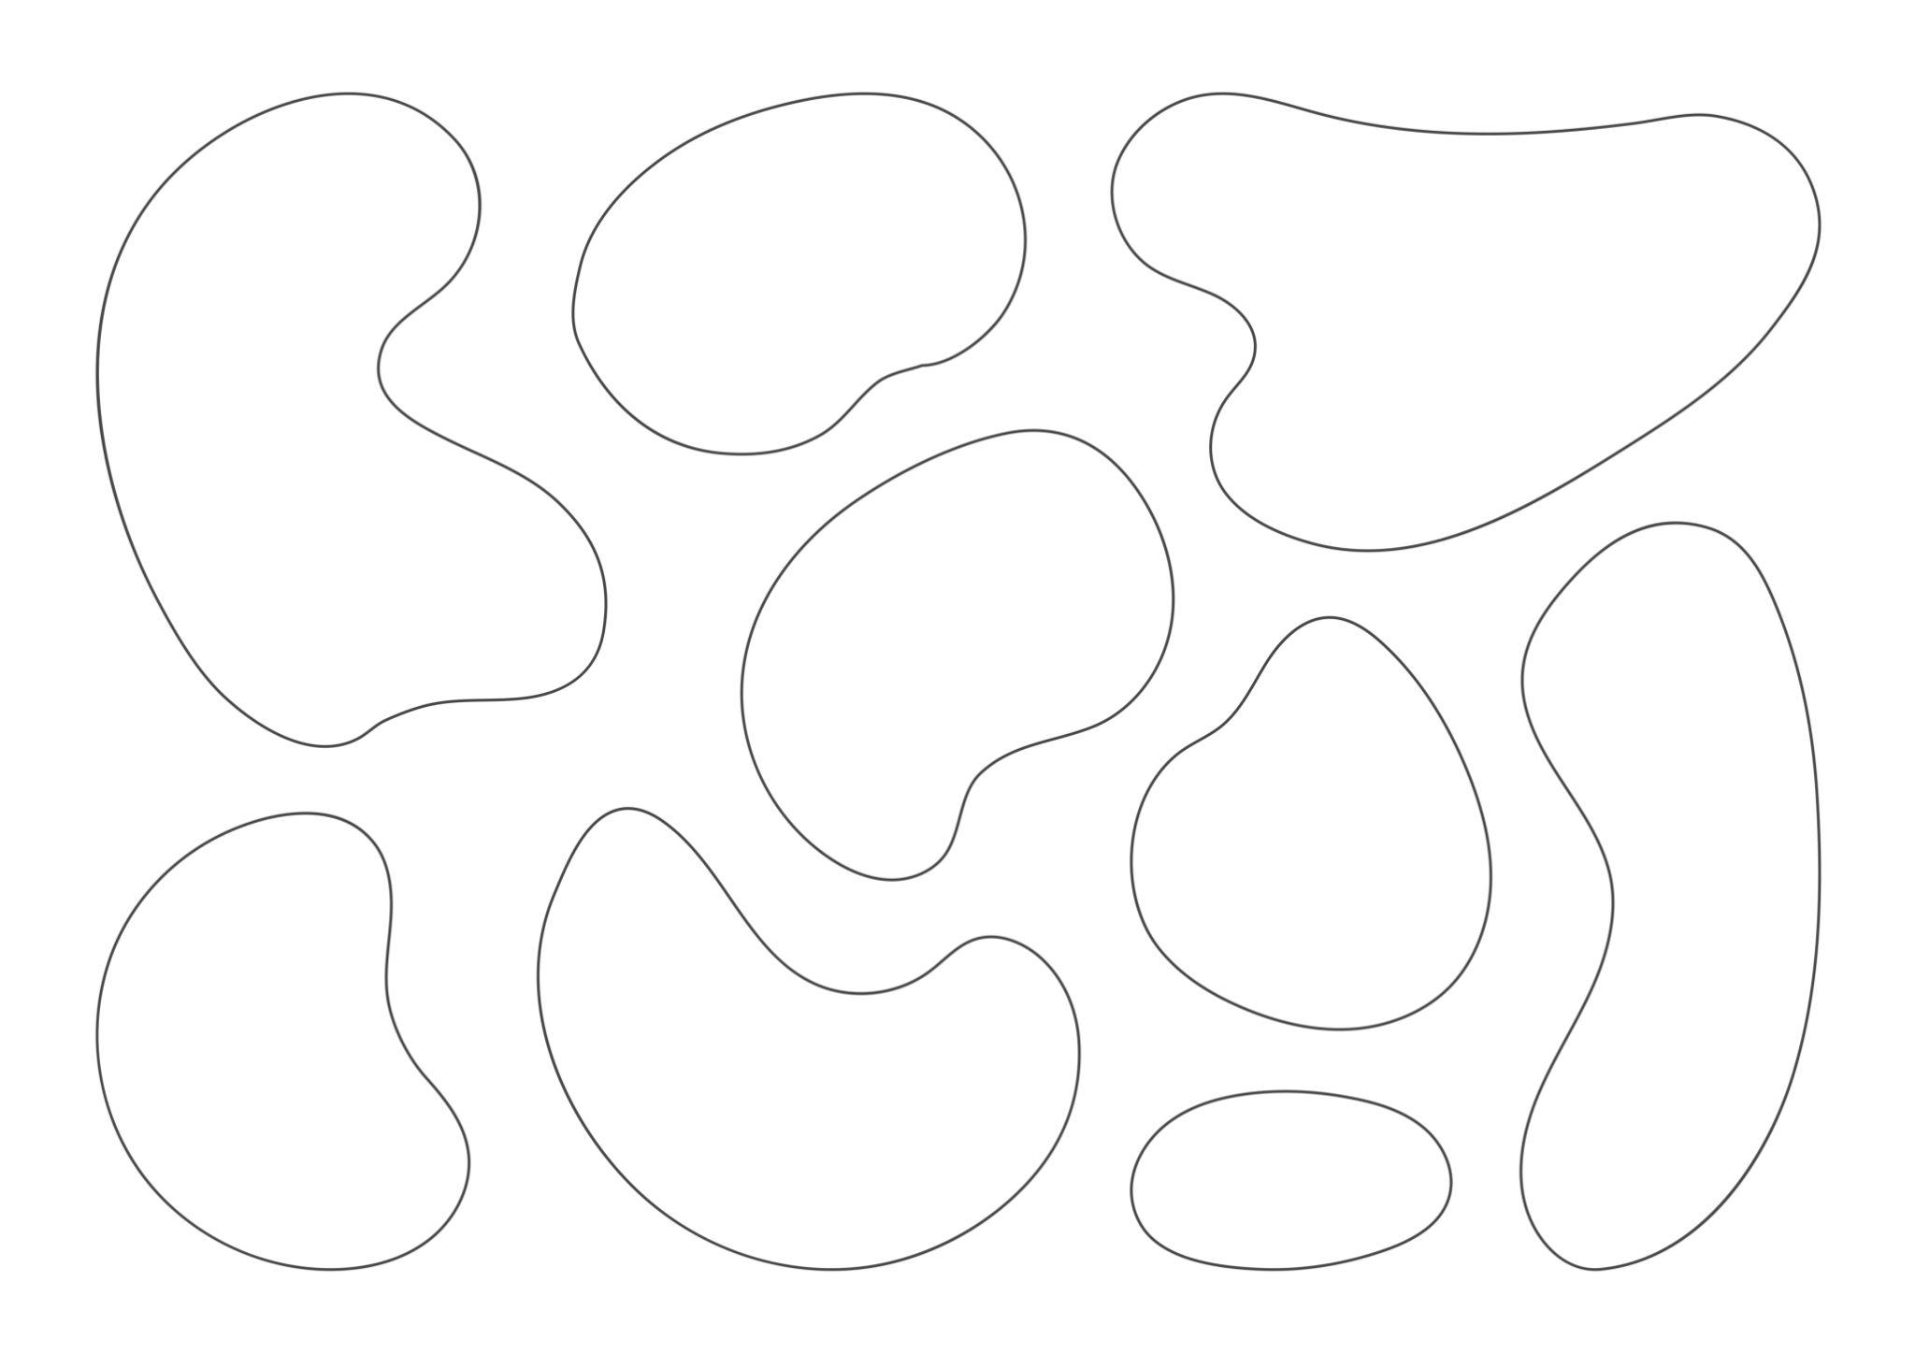
Blob shapes are frequently used in graphic and UI design because their boundaries can flow freely without rigid geometric constraints.

4. Pebble-Like Shapes
# Source: AI Source: Provided by: [Data Path: Persons Table -> ID Column: 1, Name_En Column: Motasem Essam] -> From: [ChatGPT] on [7/25/2026]
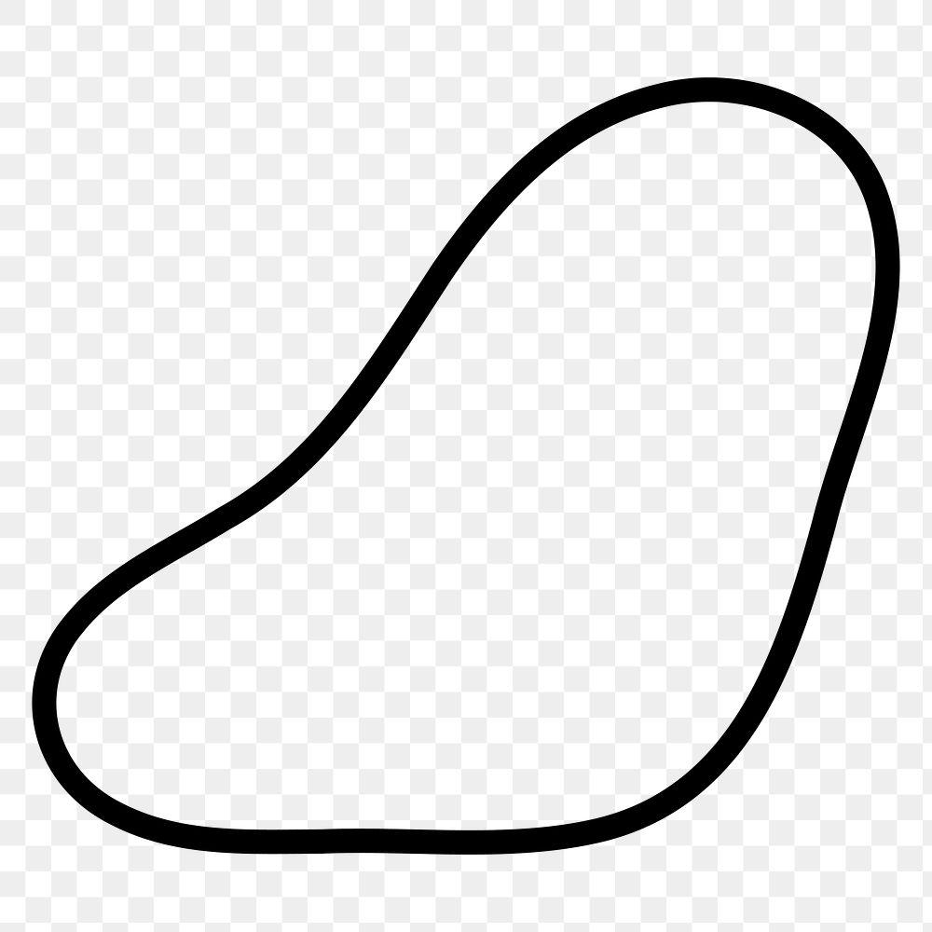
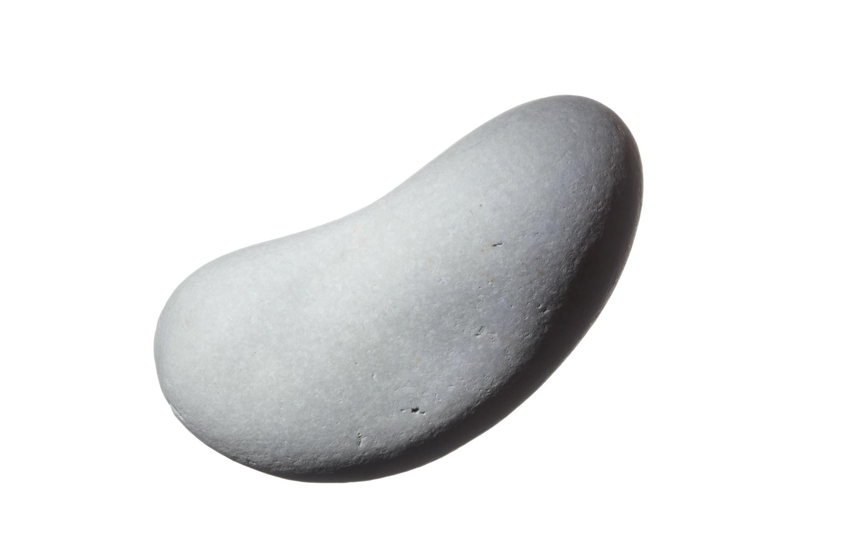
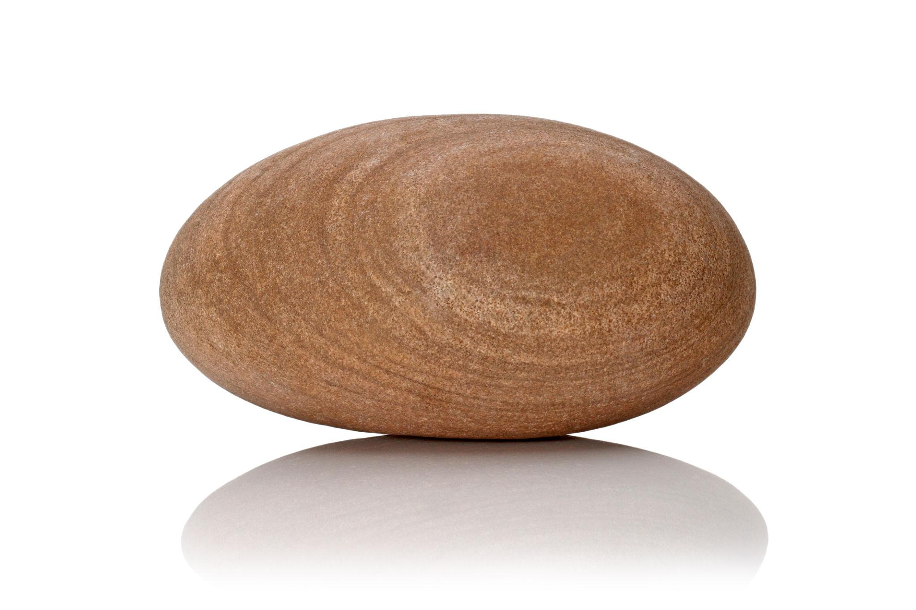
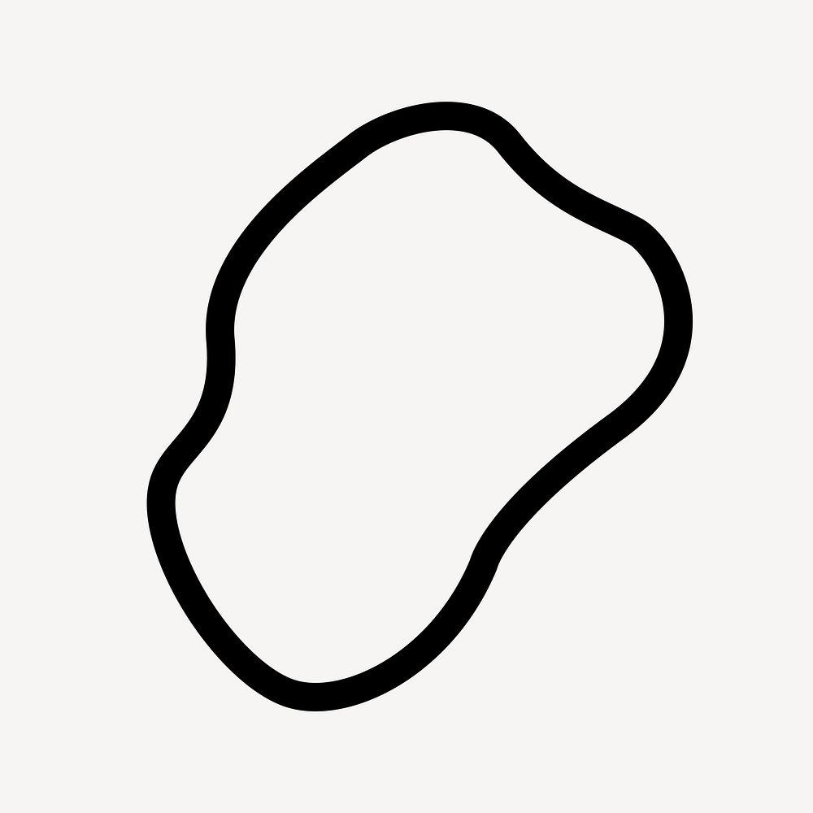
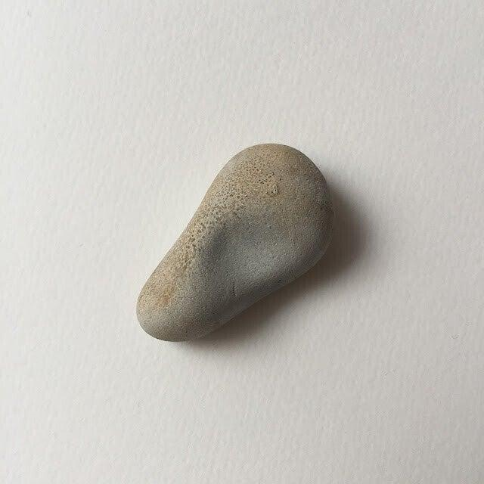
Pebble-like forms have smooth but irregular curved boundaries.

Organic vs. Geometric Curved Shapes
# Source: AI Source: Provided by: [Data Path: Persons Table -> ID Column: 1, Name_En Column: Motasem Essam] -> From: [ChatGPT] on [7/25/2026]
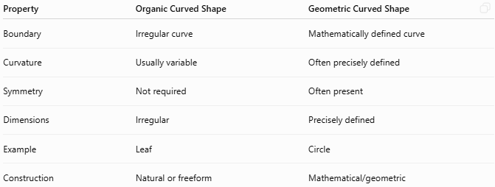
Property | Organic Curved Shape | Geometric Curved Shape
Boundary | Irregular curve | Mathematically defined curve
Curvature | Usually variable | Often precisely defined
Symmetry | Not required | Often present
Dimensions | Irregular | Precisely defined
Example | Leaf | Circle
Construction | Natural or freeform | Mathematical/geometric

Organic vs. Freeform Curved Shapes
# Source: AI Source: Provided by: [Data Path: Persons Table -> ID Column: 1, Name_En Column: Motasem Essam] -> From: [ChatGPT] on [7/25/2026]
These categories are closely related but not identical.
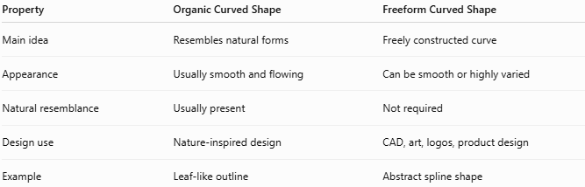
Property | Organic Curved Shape | Freeform Curved Shape
Main idea | Resembles natural forms | Freely constructed curve
Appearance | Usually smooth and flowing | Can be smooth or highly varied
Natural resemblance | Usually present | Not required
Design use | Nature-inspired design | CAD, art, logos, product design
Example | Leaf-like outline | Abstract spline shape
A shape can therefore be both organic and freeform.

Organic Curved Shapes vs. Natural Irregular Curved Shapes
# Source: AI Source: Provided by: [Data Path: Persons Table -> ID Column: 1, Name_En Column: Motasem Essam] -> From: [ChatGPT] on [7/25/2026]
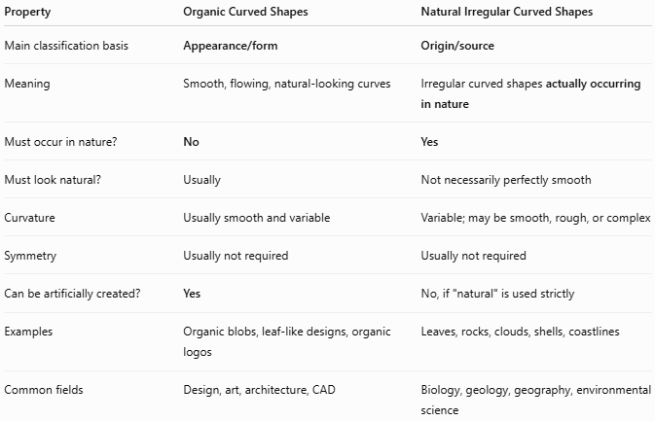
Property | Organic Curved Shapes | Natural Irregular Curved Shapes
Main classification basis | Appearance/form | Origin/source
Meaning | Smooth, flowing, natural-looking curves | Irregular curved shapes actually occurring in nature
Must occur in nature? | No | Yes
Must look natural? | Usually | Not necessarily perfectly smooth
Curvature | Usually smooth and variable | Variable; may be smooth, rough, or complex
Symmetry | Usually not required | Usually not required
Can be artificially created? | Yes | No, if "natural" is used strictly
Examples | Organic blobs, leaf-like designs, organic logos | Leaves, rocks, clouds, shells, coastlines
Common fields | Design, art, architecture, CAD | Biology, geology, geography, environmental science

Open and Closed Organic Curves
# Source: AI Source: Provided by: [Data Path: Persons Table -> ID Column: 1, Name_En Column: Motasem Essam] -> From: [ChatGPT] on [7/25/2026]
Closed Organic Shape
A curve returns to its starting point and encloses a region.
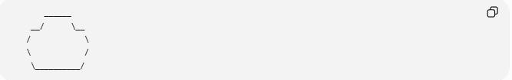
______
__/ \__
/ \
\ /
\__________/
Open Organic Curve
The endpoints remain separate.
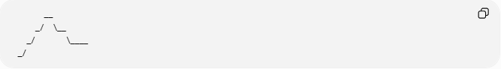
__
_/ \__
_/ \____
_/

Mathematical Representation
# Source: AI Source: Provided by: [Data Path: Persons Table -> ID Column: 1, Name_En Column: Motasem Essam] -> From: [ChatGPT] on [7/25/2026]
Organic shapes usually cannot be represented by one simple geometric equation.
They can be modeled using:
Parametric Curves
$$x=x\left(t\right), y=y\left(t\right)$$
Bézier Curves
$$B\left(t\right)={\left(1-t\right)}^{3}P_{0}+3{\left(1-t\right)}^{2}tP_{1}+3\left(1-t\right)t^{2}P_{2}+t^{3}P_{3}$$
Splines
Multiple curve segments can be joined together to produce a smooth organic boundary.

Area and Perimeter
# Source: AI Source: Provided by: [Data Path: Persons Table -> ID Column: 1, Name_En Column: Motasem Essam] -> From: [ChatGPT] on [7/25/2026]
For a closed organic shape, the area is the region enclosed by its curved boundary.
Depending on the available representation, its area can be calculated or approximated using:
- Grid approximation.
- Coordinate methods.
- Numerical integration.
- Computational geometry.
- Digital image analysis.
The perimeter is the total length of the curved boundary.
For a parametric boundary:
$$L=\int_{a}^{b}{\sqrt{{\left(\frac{dx}{dt}\right)}^{2}+{\left(\frac{dy}{dt}\right)}^{2}}},dt$$

Applications
# Source: AI Source: Provided by: [Data Path: Persons Table -> ID Column: 1, Name_En Column: Motasem Essam] -> From: [ChatGPT] on [7/25/2026]
Organic curved shapes are widely used in:
- Plane Geometry
- Biology
- Botany
- Architecture
- Product Design
- Industrial Design
- CAD
- Computer Graphics
- Animation
- Logo Design
- UI/UX Design
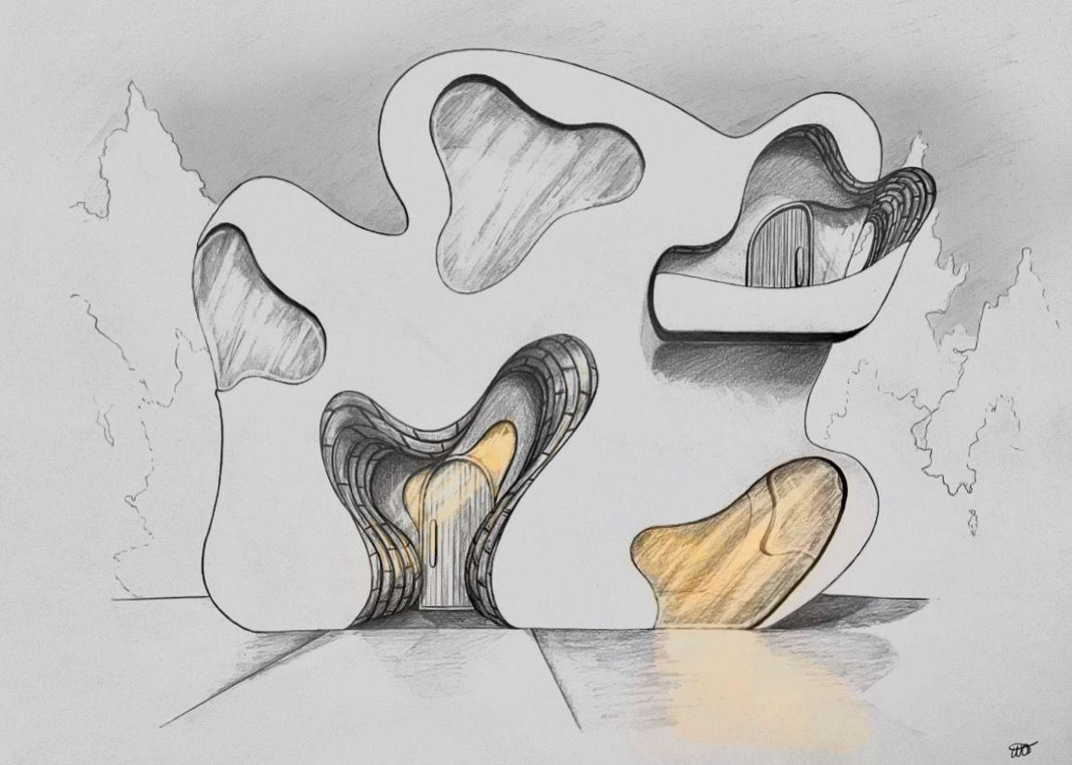
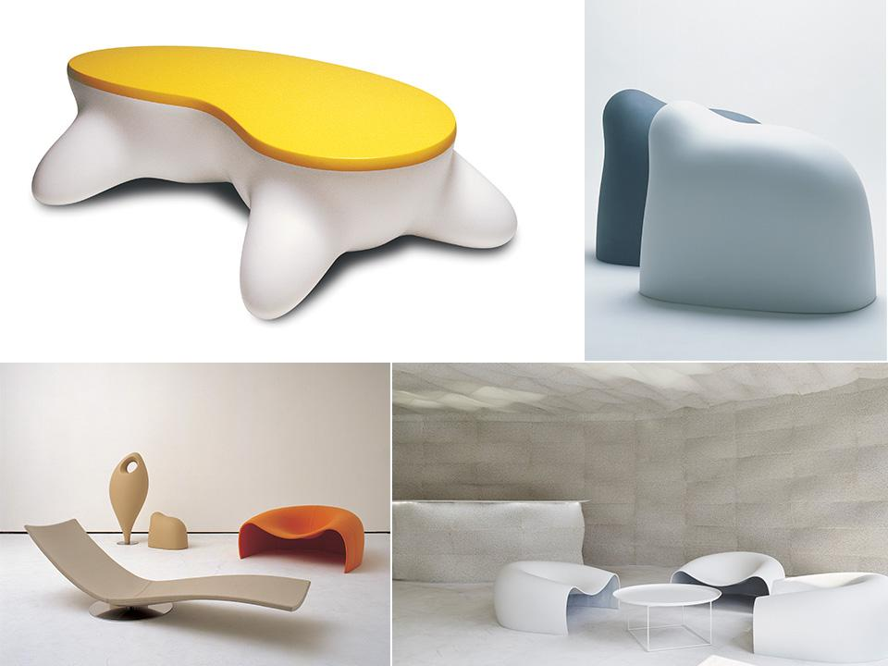
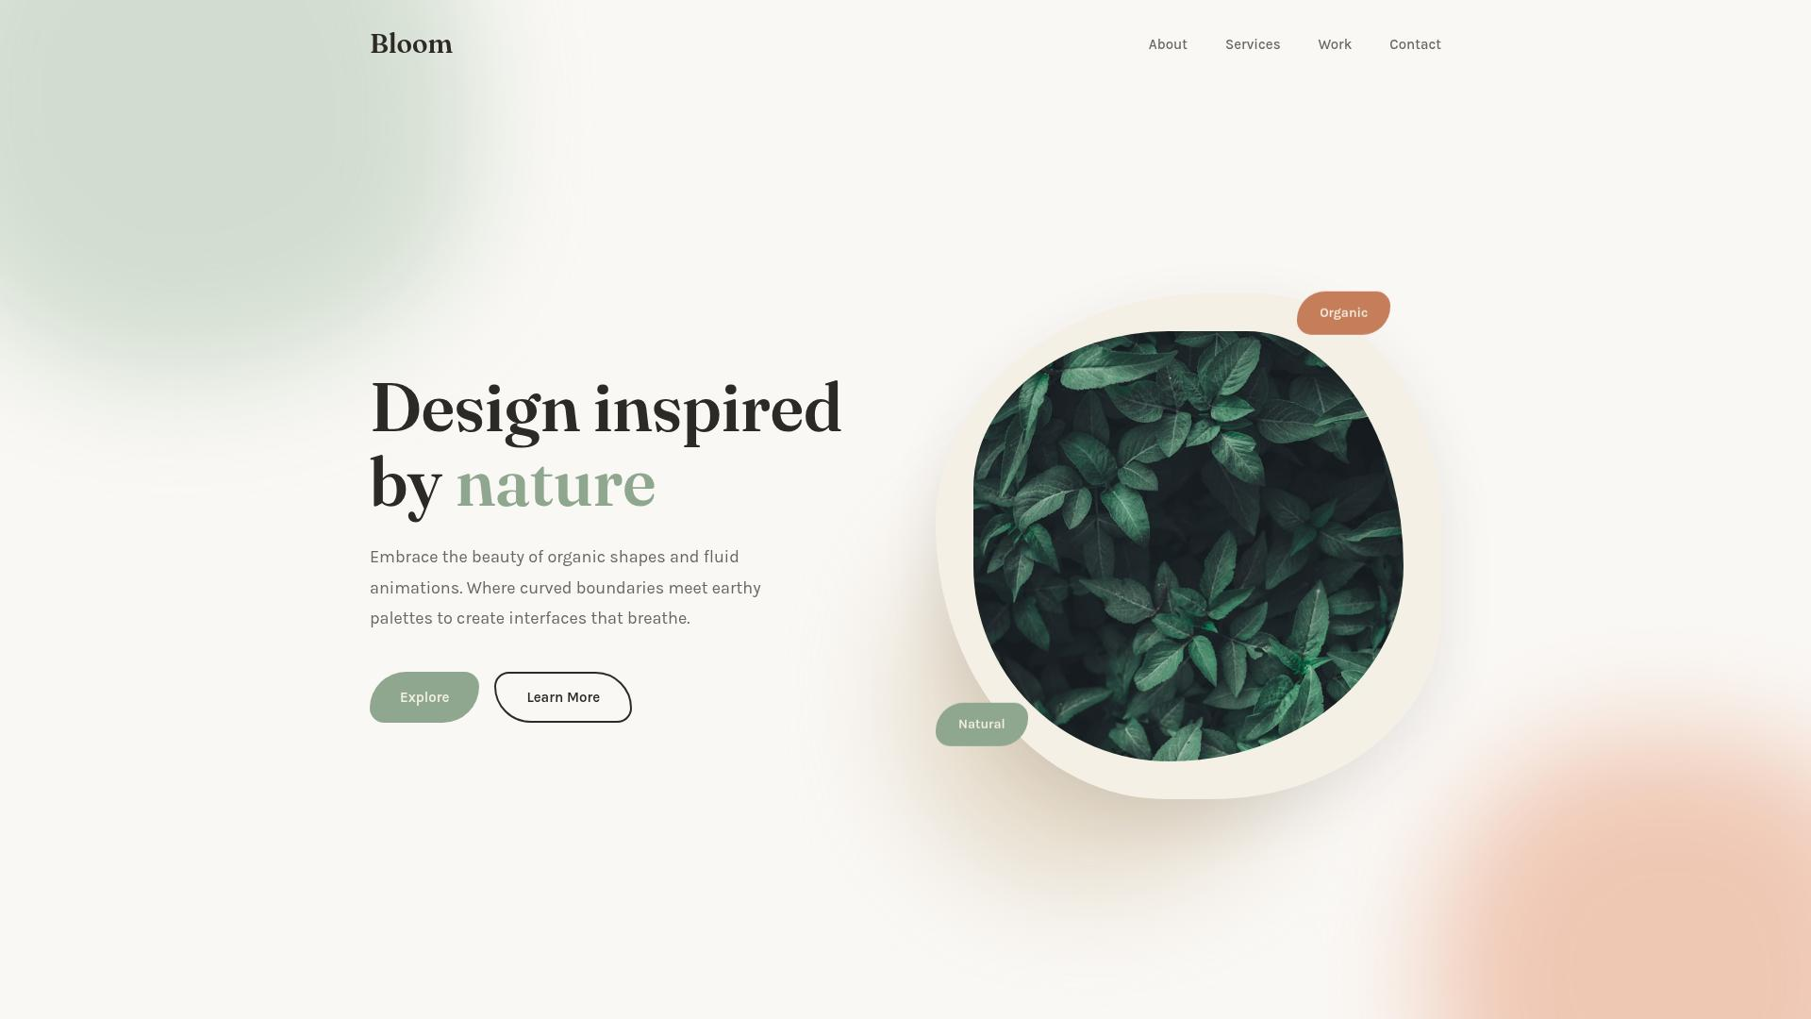
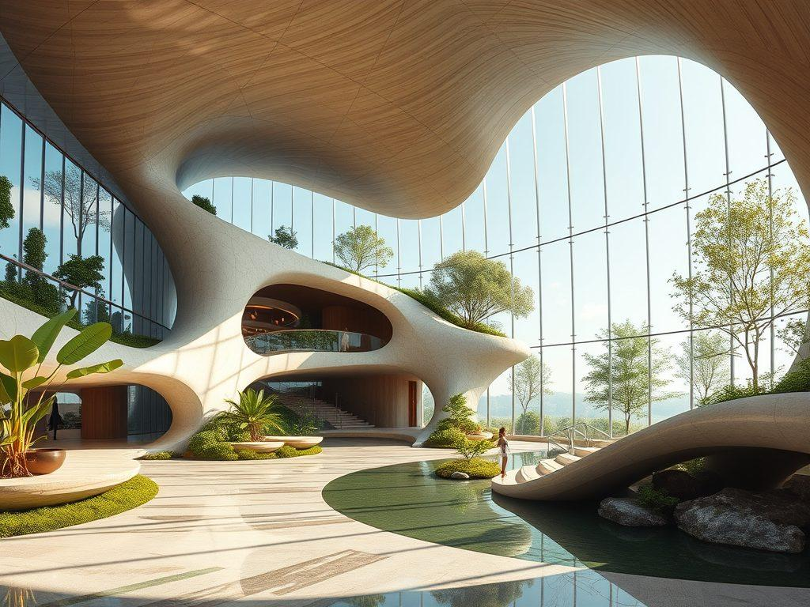
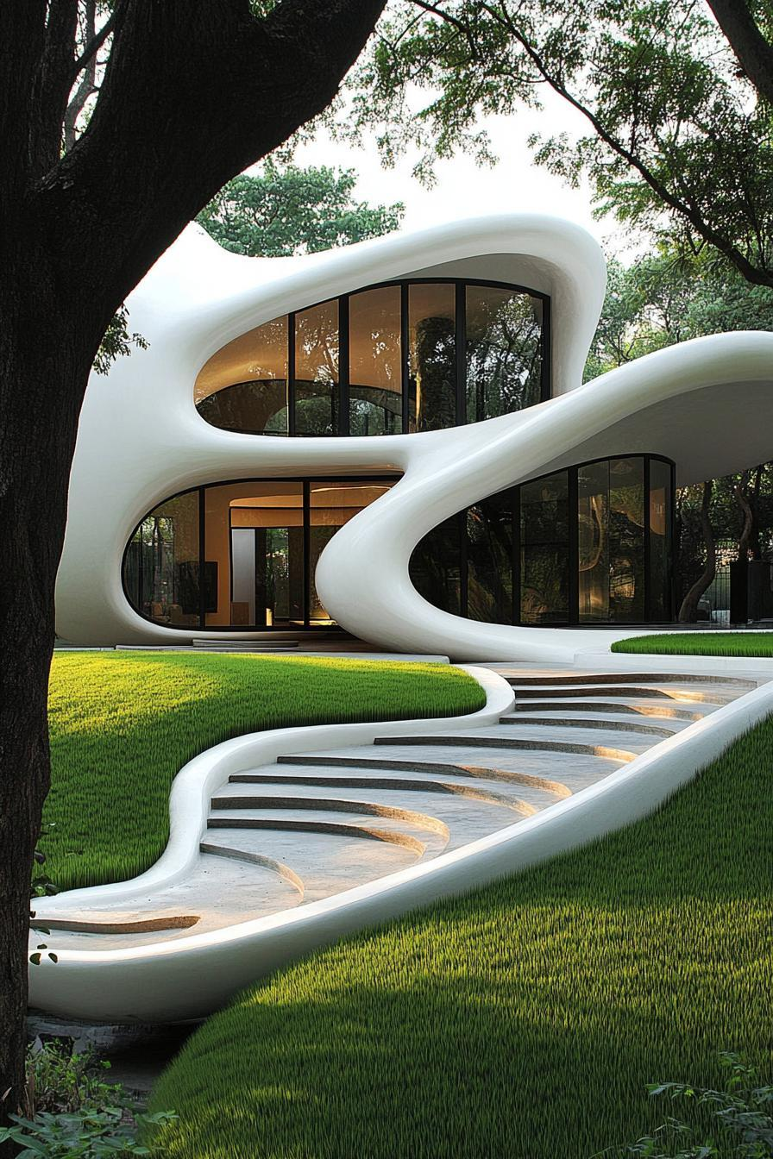
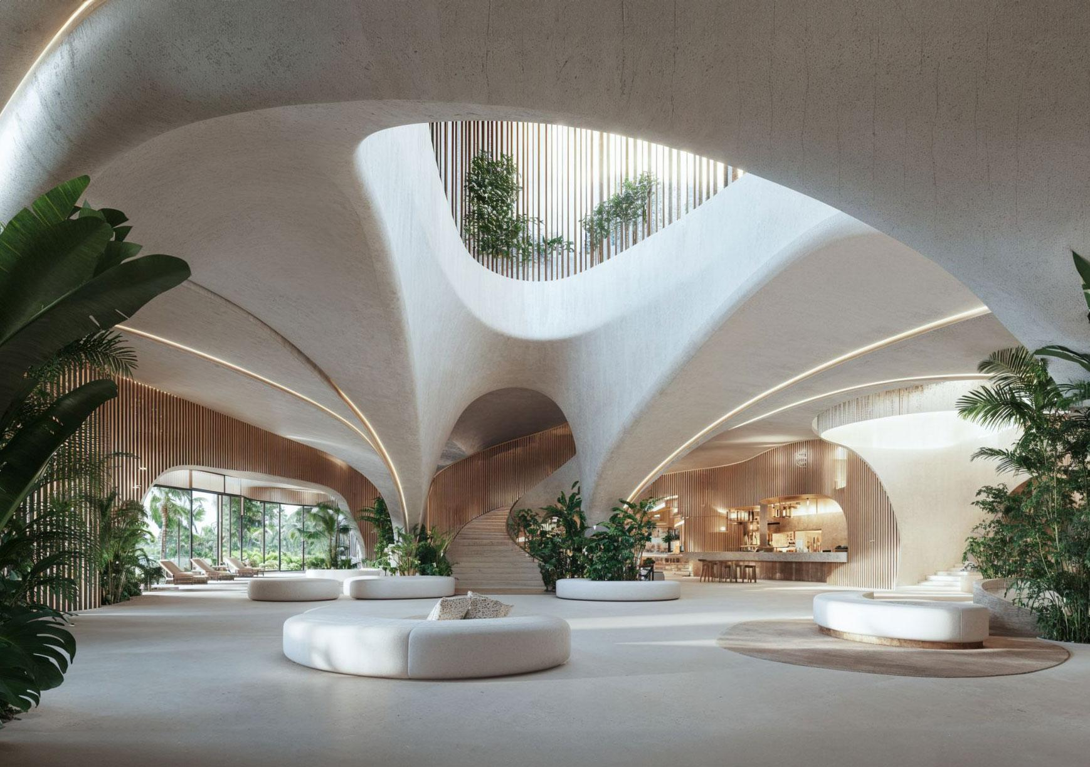
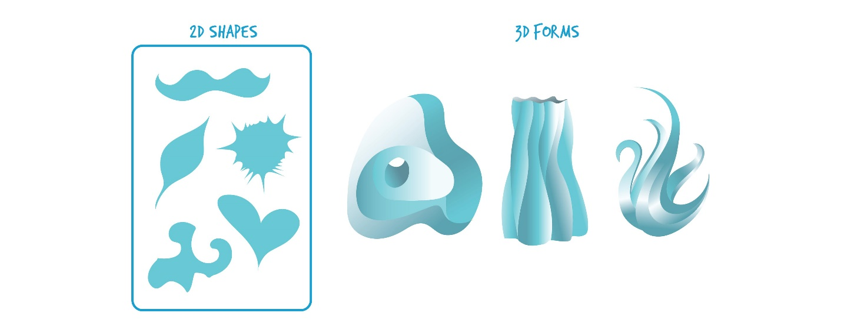

Key Points
# Source: AI Source: Provided by: [Data Path: Persons Table -> ID Column: 1, Name_En Column: Motasem Essam] -> From: [ChatGPT] on [7/25/2026]
$$\boxed{\text{Organic Curved }\text{ShapeIrregular}+\text{Curved}+\text{Natural/Flowing Appearance}}$$
Common examples include:
- Leaf-like shapes.
- Cloud-like shapes.
- Blob shapes.
- Pebble-like shapes.
- Biological forms.
- Nature-inspired designs.

Conclusion
# Source: AI Source: Provided by: [Data Path: Persons Table -> ID Column: 1, Name_En Column: Motasem Essam] -> From: [ChatGPT] on [7/25/2026]
Organic Curved Shapes are irregular curved forms characterized by smooth, flowing, and often asymmetric boundaries. They commonly resemble forms found in nature and living organisms, although they can also be intentionally created in art, design, architecture, and engineering. Unlike precisely defined geometric curves, organic shapes generally have variable curvature and do not follow a fixed mathematical pattern. They are an important category of irregular curved shapes, particularly in biology, CAD, product design, architecture, computer graphics, and visual design.

